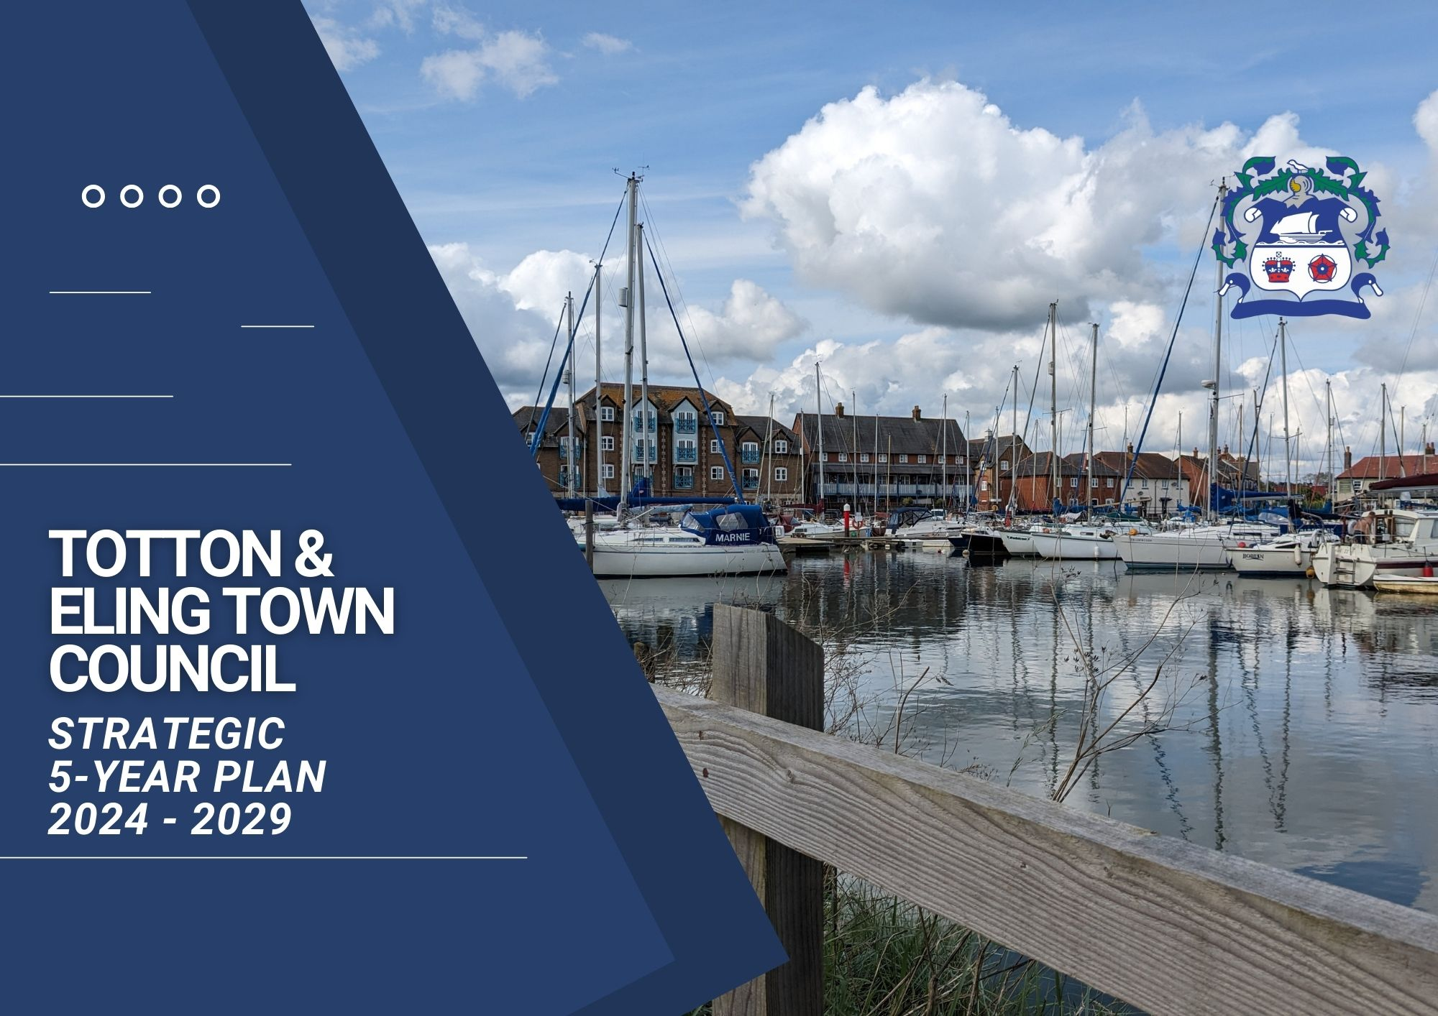
Context | 2 | What we do?  - What achieved last year | 13/14
Mission statement, Core values, Map and Introduction | 3-10 | What do we want to do next?  - Ambitions | 14/15-66
The Planning Cycle | 11 | List of Achievements 25-26 | 67-76
What is a Town Council | 12 | List of Achievements 24-25 | 77-89
What can we do?  - Powers and Duties  - Accountability | 12 | Review | 90
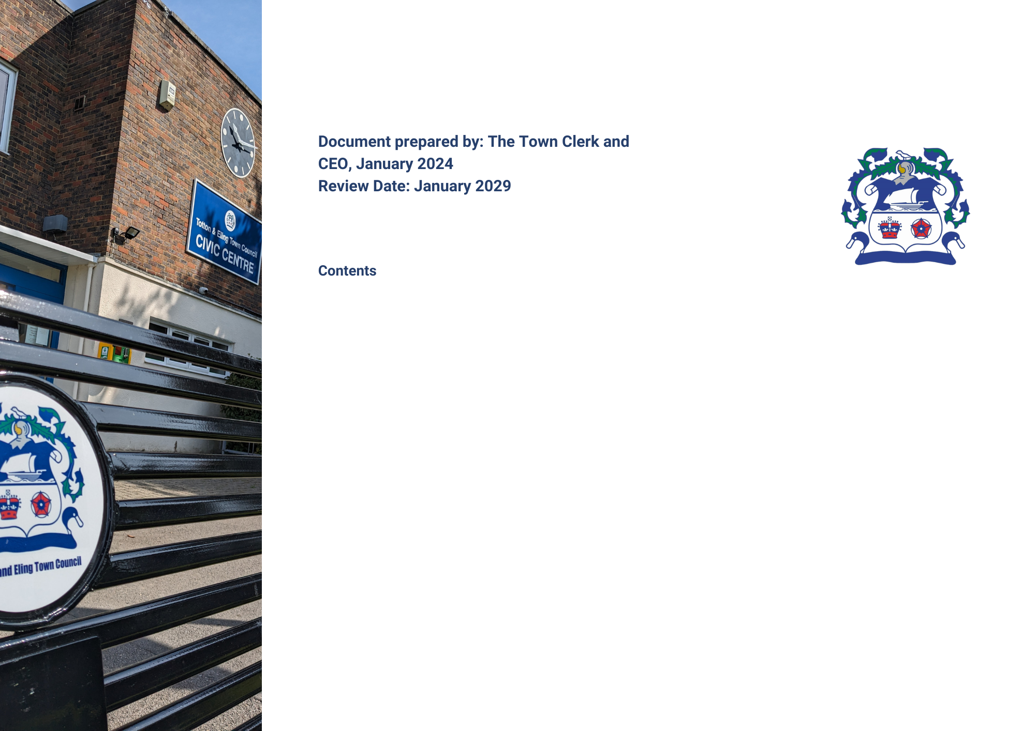

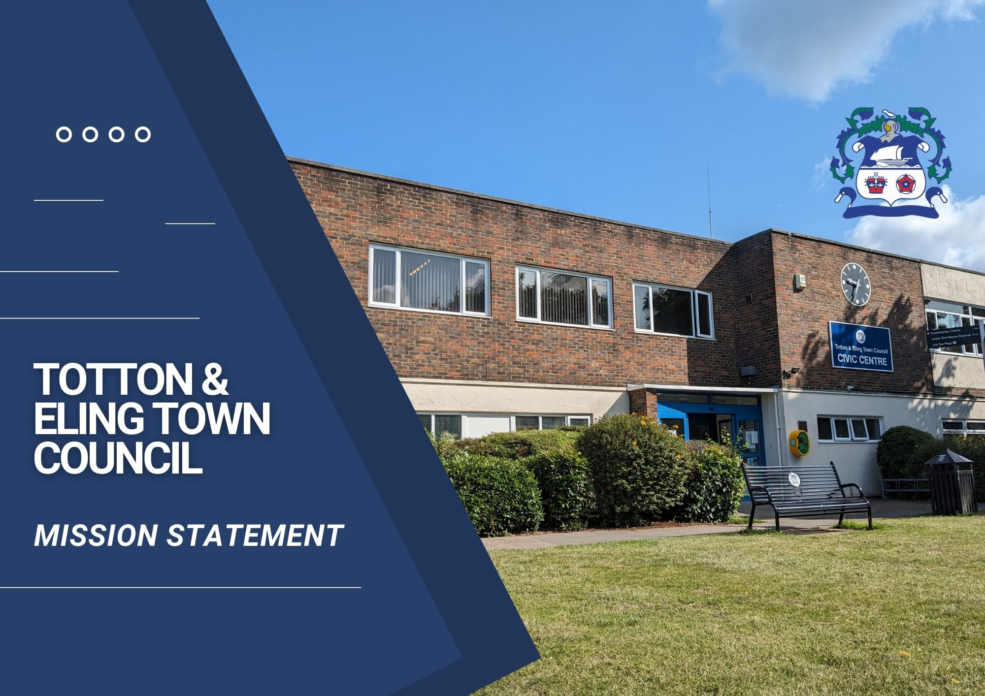

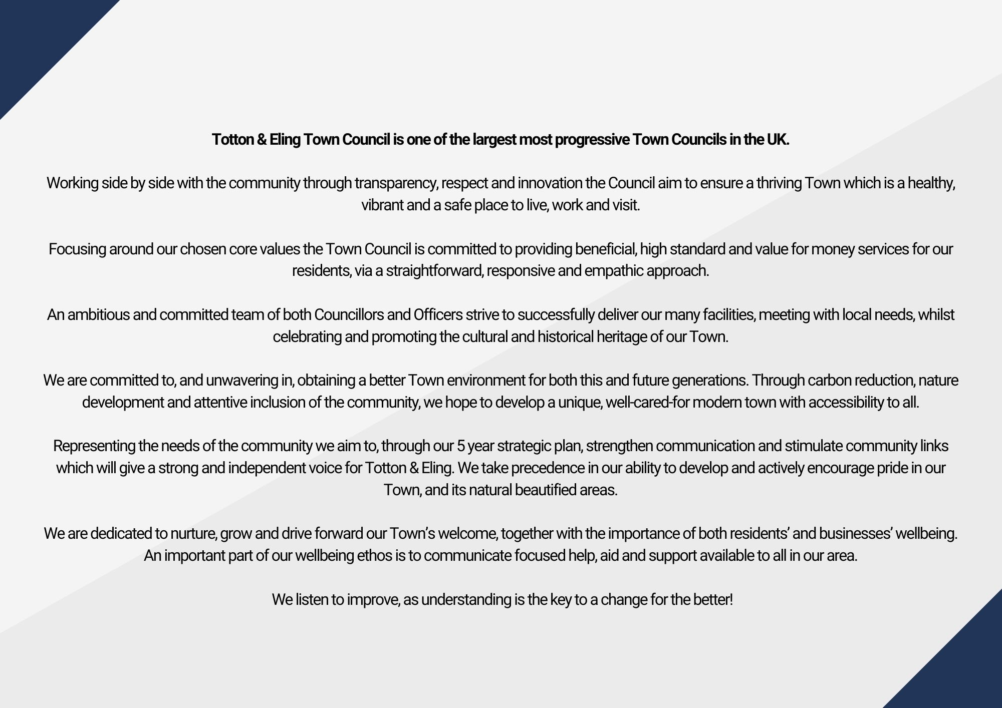

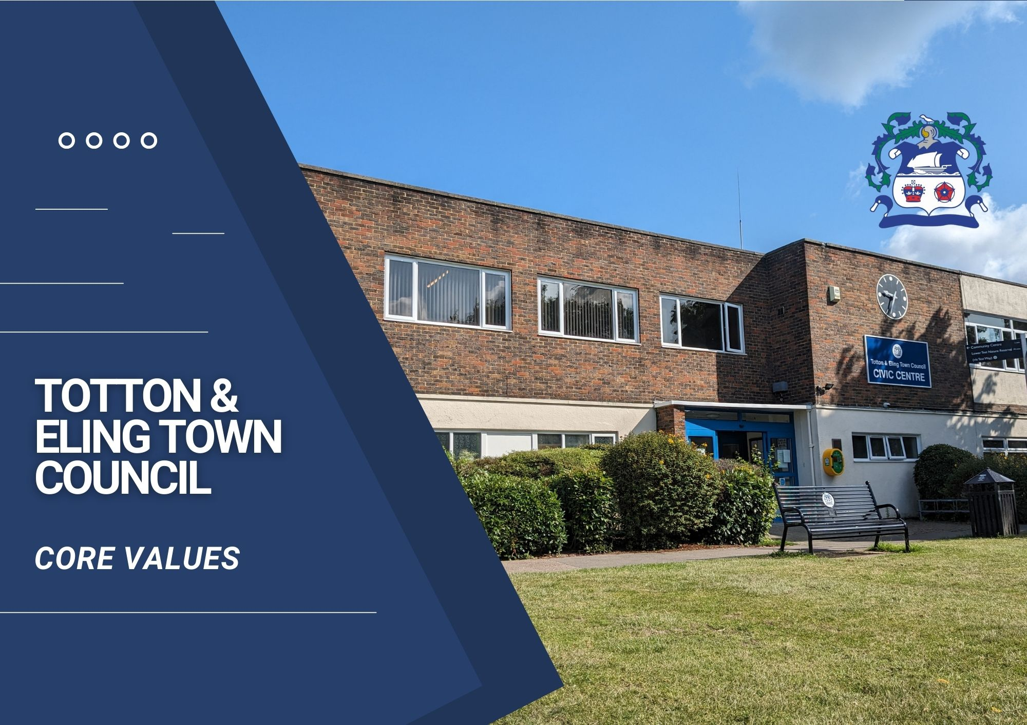

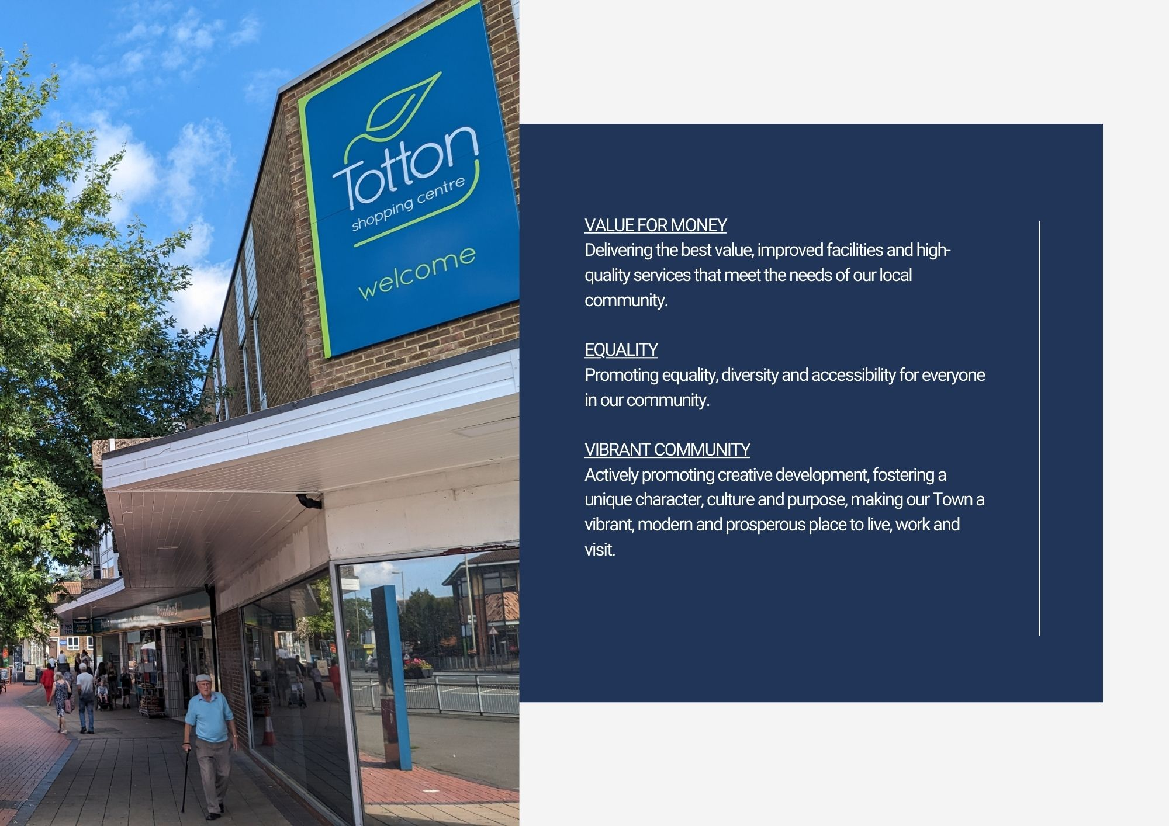

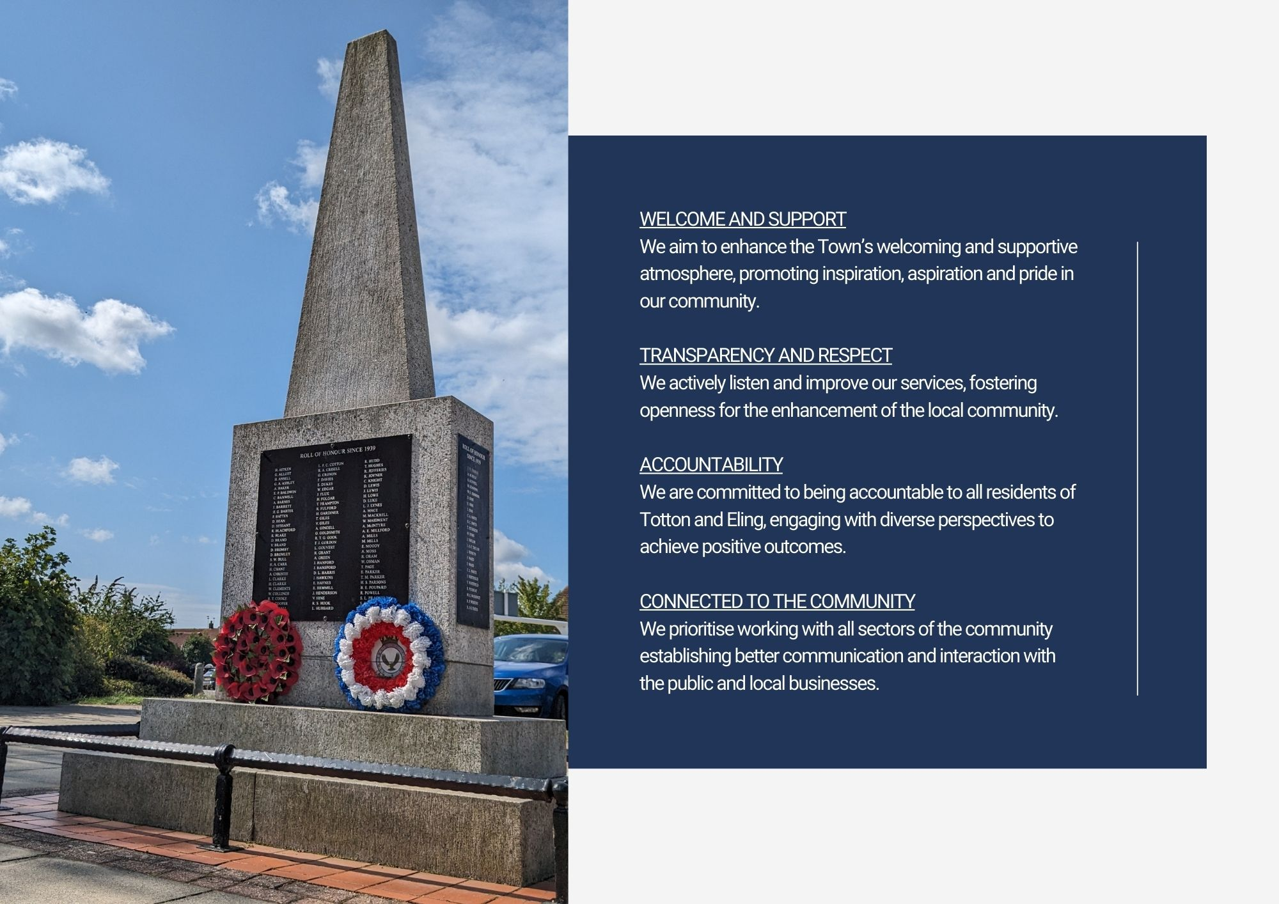

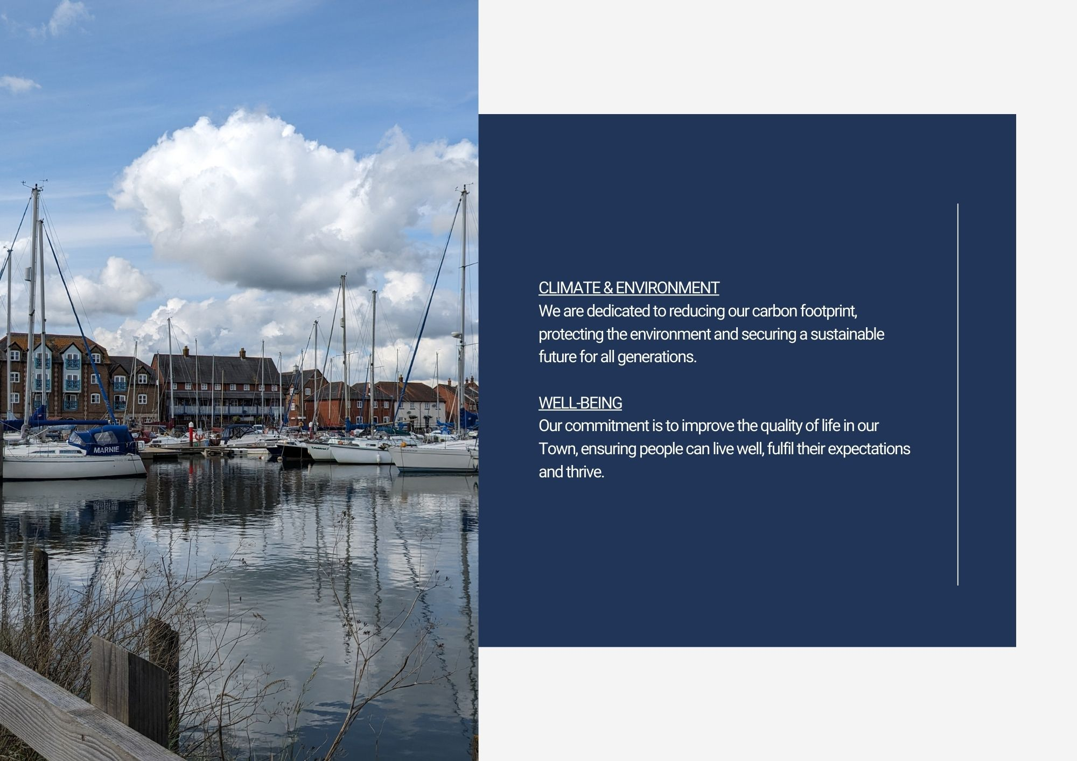

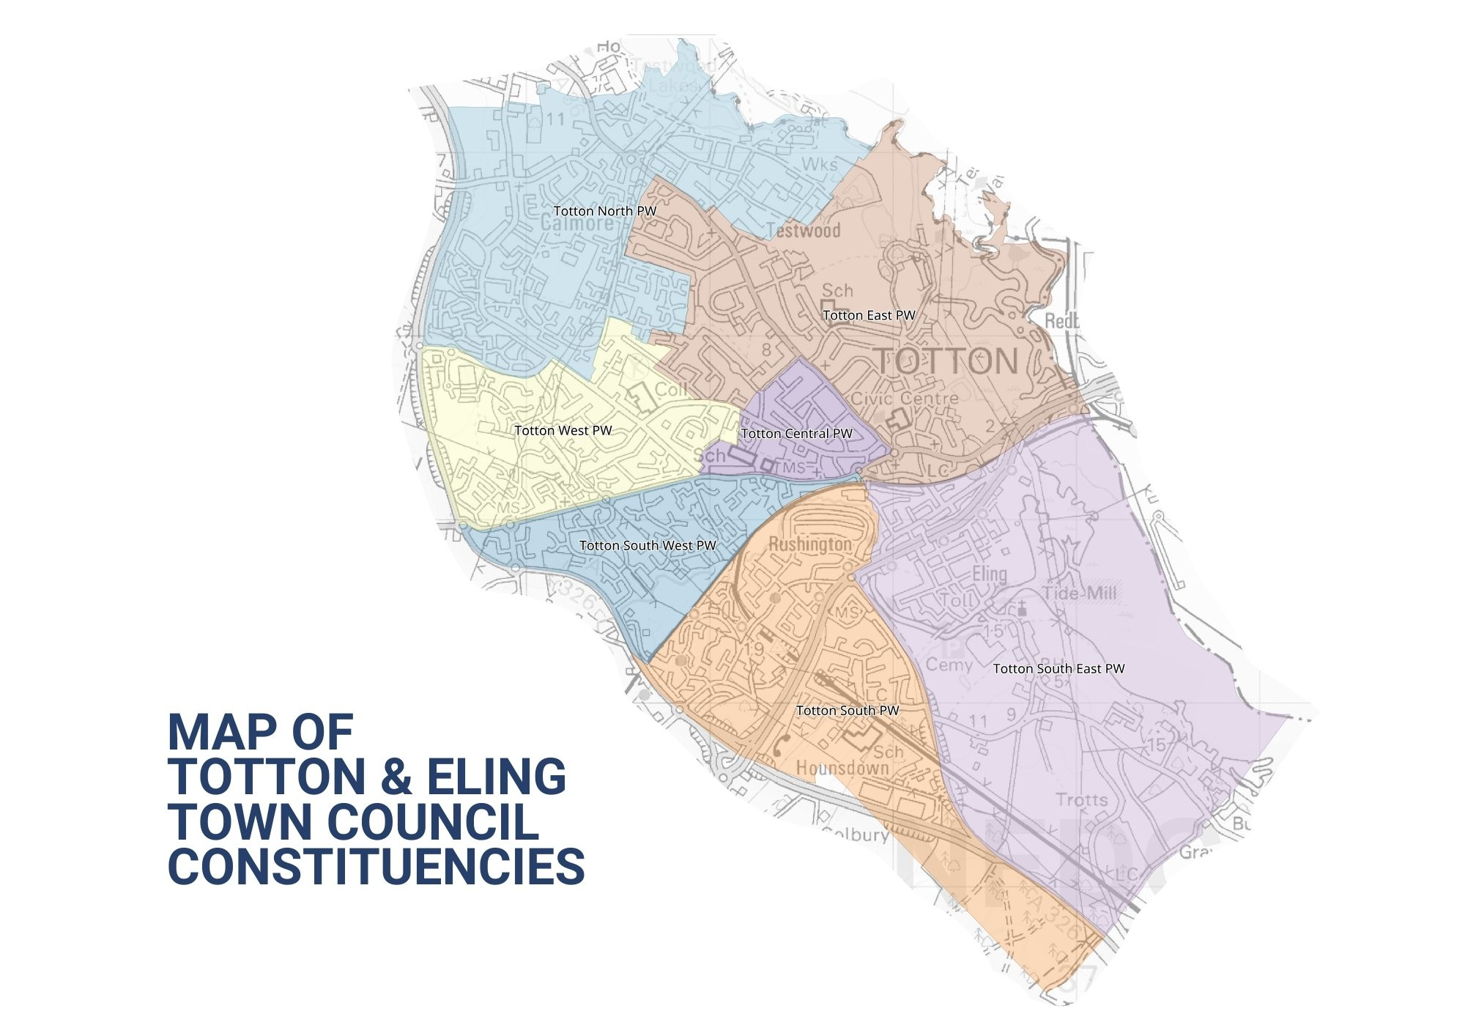

Introduction

Welcome to Totton and Eling Town Council. This is our Strategic Plan – it sets out what we are going to do over a rolling year period of five years and is a statement that we must be a Town Council that is relevant and responsible. The Plan takes into account the issues facing us and our ability to respond with the resources available. It makes clear there will be choices, and how the Council will decide which to prioritise.

The Plan has been approved by your Town Councillors. It is essentially a planning tool to assist us with the practical decisions we have to take when we meet bi-monthly, supported by a review process that helps us look back on our performance. By publishing our Strategic Plan, we can help those who live, work or visit the Town see what we are doing on their behalf. The Council has devised pillars or themes that will be referred to in the plan and will form the basis for the Council’s strategic aims and will comply with its code of conduct and Nolan principles, which include selflessness, integrity, objectivity, accountability, openness, honesty and leadership.

Context

This is our first Strategic Plan, prepared at a time of austerity across society when all organisations that provide services to the community, be they public, private or voluntary are facing cost pressures and resource restrictions. The emphasis is on value for money, efficiencies, collaboration and accepting that some things just will not get done. Through a planning process though, we can have a shared vision and direction, protect what is important and consider new ways of implementing progress. The ambitions and projects included in this plan have been approved, in principle, by the Council as areas to support and resource. All projects/ambitions, which the Council feel best meet with local needs and priorities, will be kept under review and will be amended and updated as circumstances change. The Town Council have recognised the importance of establishing a Mission statement, and set of core values, which are reflected in the plan, and which are at the heart of how we operate and conduct Council business.

Totton and Eling Town Council, as the first tier of Local Government, is uniquely situated to provide the forum for understanding and supporting the needs of this community.
It provides advocacy on behalf of its residents, uses linkages to other organisations to bring in services, or directly procures them itself. Liaison with New Forest District Council happens at all levels, and there are also association to health and social care as well.
Day-to-day, the Council will seek solutions for the community, looking for skills and volunteers to make improvements to our surroundings or bringing particular neighbourhood issues to local attention to promote a better quality of life for all.

Above all your Town Council is here to help, support and encourage. This Plan tells you how.

The Planning Cycle

Planning (and performance) is a continuous process of gathering and assessing information, formulating actions, doing them, and then reviewing performance and gathering again.

Once specific actions are agreed to deliver this Plan, they are entered on the Actions/Task Register, which is monitored at every weekly meeting by the Town Council’s Senior Leadership Team and also at monthly meetings held with the Committees Chairs.

Association

This plan is linked very closely to the allocation of resources – mostly financial, but people’s time and energy too. Our finance is mostly derived from the Council Tax system, which follows the financial year April to March. Our precept, or ‘demand’, placed upon the Council Tax system has to be declared by January each year, in order that New Forest District Council can calculate the overall tax collection sums for each eligible household and produce the billing required. Other income is sourced through service provision.

Key dates

Therefore, this Plan will be monitored and updated, allowing it to evolve as the budget is also prepared, for final precept calculations in November. The Plan cycle will run from April to March, to match the funding available, and will be reviewed at monthly Chairs of Committee and Senior Management Team meetings to assess achievements in the previous cycle, and progress in the current one.

What is a Town Council?

A civil Town or Parish is an independent local democratic unit for villages, Towns, and suburbs or urban areas. Each Town/Parish has a Parish (or Town) meeting consisting of all its local government electors and most (where the electorate exceeds 200) have a Parish or Town Council. Over 13 million people live in such parishes, with approximately 30,000 in the Town of Totton and Eling. The Town Council is supported by Officers employed within each service area to deliver both the Council’s services and policies, together with ensuring decisions are implemented appropriately.

The Town Council is a local authority. Its Councillors are elected for four years at a time in the same way as for other Councils. Bye-elections may be held to fill vacancies occurring between elections, or members may be co-opted onto the Council if no election is called. The Council is the corporation of its Town in the New Forest area, it covers the Town of Totton and Eling. In May each year the Councillors choose a Chairperson and Vice Chairperson from amongst their number. In Totton and Eling, there are 20 Councillors who make up the Town Council, which employs a Clerk to manage administration and the day-to-day running of the Council and its facilities. The Town Council will adhere to good governance and best practice via its adopted and published policies/procedures and act in the interests of local people in making representation.

What can we do?

Powers and Duties

Town Councils have a number of formal powers, set out in a wide range of legislation. A duty is something that a Council must do, a power is something that it may do, if it so decides. A Town Council cannot do anything that is not permitted by law.

The Town Councillors know the Town and can now (and increasingly often do) represent their views directly to other authorities like the District and County Council at its Area Boards, Health Authorities, Police and Fire Authorities meetings.
They are entitled to be consulted on planning applications, which include work to listed buildings and on proposals in conservation areas and are often consulted on such things as schools and roads. They put the Town’s case at public inquiries.
There is the power to create a Neighbourhood Plan which allows local people to get the right development for their community, but the plans must still meet the needs of the wider area.

Accountability

You elect its members every four years – the next time will be May 2027 – and you are entitled to attend the Annual Town meeting between March and June each year and to say what you think. You can also go to every meeting of the Town Council and meet the Council members, listen to their business, and participate during the time especially set aside for that purpose at the start. The accounts are strictly audited every year and published.

You can find out more about what we do, how we do it, and our meetings on the Town’s website at http://www.tottoneling-tc.gov.uk

What do we do?

The Town Council provides a number of direct services to the community and acts as custodian to a number of assets held in the ‘public name’ and provide the following services:

Allotments Parks & Open Spaces Outdoor paddling pools and splash park Leisure & sports facilities
Halls for Hire Public conveniences Memorials Public notice boards
Boat moorings Bus shelters Community safety warden Heritage site and café
Skate park Cycle track Town benches Walking routes

Although New Forest District Council is the Planning Authority, the Town Council is consulted on each planning application made in the Town. Councillors consider planning applications at their meetings and inform New Forest District Council of their views and recommendations.

At each meeting of the Council, reports from a variety of Town organisations are received, and Councillors seek to provide support where necessary or requested in order that local groups can continue to thrive.
Each meeting considers issues for our communities such as planning (for example, housing, change of use or tree felling) crime and community safety, facilities for all generations, or items of maintenance in the ‘public realm’ that need reporting to appropriate authorities. The Council can act as advocate for residents, a conduit for communicating information, and will liaise with appropriate departments of other public authorities to ensure that views, comments and necessary actions are dealt with.

What we achieved in the last year

Between 2023 and 2024, we have achieved a wide range of improvements, both to the way we work, and to the community we serve. These are listed later in this document.

Established policy reviews and formulation such as Equal Opportunity, Members and Officers Best Practice, Annual Leave and a General Reserves Policy are but a few actioned during 2023/24.

Considered: planning applications, grant applications, activities, events, legislation, projects, most of which were supported by the Council together with policies and procedures.

What do we want to do next?

The Town Council has worked through the Town’s Committees and Group’s findings and has developed a 5-year Strategic Plan. This plan has been built around our Mission Statement, Core Values and public consultation. As a live document it will be expanded and evolved as it develops.

The table attached sets out the Strategic Plan adopted by the Council, and which will be implemented over the next five years:

5 YEAR PLAN

WELLBEING, HEALTH & SAFETY – Supporting life satisfaction, achievement and security.

Ambition | Council Committee/  Department | Timescale | Success would be | Progress At:  29/07/26
Formulation of a Youth Council | Wellbeing Group  Policy & Resources Committee | 0 – 1 year | To implement and support a well-attended Youth Council, encouraging good communications with the Council and for young people to take part in the democratic governance of the Town. | First school visit by appointed Councillors took place in October 2024. Various ideas were discussed, including a return visit for Councillors to address the School’s Youth Council. A list of Youth contacts is presently being compiled, with a view to the Town Council arranging a meeting with those Young people. This is to be tied in with obtaining youth input on the neighbourhood Plan.  On-going.
Resident’s Forum | Wellbeing Group  Policy & Resources Committee | 0 – 1 year | Giving residents a voice and allowing them to advise the Council of issues, and requests. Additionally, providing feedback to the public, will enhance communication, confidence and thus provide a better place to live and work. | Update from meeting in April 2024 verified that existing Residents’ Associations already have strong Council liaisons. Recommendations for a residents’ evening event have now been cancelled due to lack of support. On-going
Business Forum | Town Clerk  Wellbeing Group | 0 – 1 year | Forming a business forum will provide support to the businesses in the Town giving the opportunity for input and thus encouraging a thriving community. | Two meetings have been held resulting in some positive feed back. A business forum social media page is being investigated. The last meeting held in May was not attended by any businesses in the Town. The Town Council aired exploring avenues of support via interested parties to aid in the formulation of a Business liaison group.
Follow and review Town Council’s Health & Safety Policy | Policy & Resources Committee | 0 – 5 years | Ensure the Town Council provide a legal, safe, and secure working environment for staff, Councillors, volunteers and service users. | Health & Safety annual audit was completed in April 2026. Policy was renewed in April 2026. Next due for renewal March 2027.  On-going
Health & Safety/Fire training for staff | Town Clerk  HR Department | 0 – 5 years | Recognising the importance of training being given to staff for their safety and wellbeing. | On-going H & S/Fire training courses organised for all staff. Fire drills are held on a 6 monthly basis.  A Health & Safety Officer has been employed to meet with current compliance levels.  On-going
Uphold diversity, equality and inclusion within the Town | Policy & Resources Committee | 0 – 5 years | By the introduction of improved facilities and open spaces the Town Council would reiterate and develop its commitment to working towards all individuals making use of those facilities in line with health & safety, legislation and inclusion. | Funding for this play equipment will be from SPF monies, and appropriate inclusive equipment is being sought. Installation of new inclusive play equipment has now been implemented, and further equipment funding is being sought. On – Going
Community Health Bus | Amenities Committee  Policy & Resources Committee  Officers | 0-3 years | Provision of a Community Health Bus which shall be primarily to furnish residents with the opportunity of taking a designated bus directly to main local hospitals will bestow a much needed service for the Town. | A bid for initial funding for the Community Health bus has is to be submitted to HCC.  On-going
IT, COMMUNICATIONS & MARKETING – Building trust, confidence and success through strengthened communication.

Ambition | Council Committee/  Department | Timescale | Success would be | Progress At:  29/07/26
Digital play area, tree, and allotment inspections | IT, Communications & Marketing Task & Finish Group  IT Officer | 0 – 2 years | More accurate and detailed digital inspections, would assist in identifying insurance liability responsibility, an improved Health & Safety focus and the implementation of preventative measures. | Equipment and software are presently being researched.  On-going
To encourage residents to have their say, and provide input and feedback to the Council via our website and social media pages | IT, Communications & Marketing Group.  IT Officer. | 0 – 5 years | Improvement of public participation in decision making and ideas/suggestions for facility provision and improvements for the Town. | Part of the Council’s IT improvements.  On-going
Support and increase the range of information available to residents in relation to community projects, activities and services. | IT, Communications & Marketing Group  IT Officer | 0 – 5 years | Improvement of communication channels to provide the community with up to date, and accurate information for the betterment of wellbeing, business and civic pride. | Part of the Council’s IT improvements. Links to support and aid groups will be incorporated into the new website for maximum awareness of what is on offer for residents. Groups are being added as part of the expansion of the new website and details of support/aid services are now, via a QR code, available in the Town Council Annual Report 2024/25. A marketing/events programme has now been formulated for increased communication with the community.  A digital screen has been placed in the Reception area for increased information for residents and businesses in the Town. The support/aid directory linked to the Town Council website is expanded on a regular basis.  On-going
Identification of IT opportunities | IT, Communications & Marketing Group  IT Officer | 0 – 5 years | By monitoring and identifying up and coming IT this will enable reform and more efficient staff and Councillor operation. | The review of Microsoft licenses has been completed and identified reductions in costs. On-going.

POLICY – Assurance of compliance, best practice and values.

Ambition | Council Committee/  Department | Timescale | Success would be | Progress At:  29/07/26
Review of Byelaws | Policy & Resources Committee  public consultation, government bodies  Town Clerk | 0 – 5 years | Reformed byelaws more relevant to the provision in the Town. Improved governance and byelaw adherence. | Anticipate commencement in Summer 2027.  On-going
On-going staff structure review. | Town Clerk  Personnel Sub Committee (if applicable) | 0-5 years | Periodic review to ensure staffing structure meets business needs and requirements. | Monitoring and assessment in progress.  On-going
Review of procurement Policy & procedure | Town Clerk  Policy &Resources Committee | 0.5 years | A review of the procurement policy is required to incorporate the procurement Act 2023, which came into effect on 24th February 2025. The aim of the new legislation is to improve the opportunity for authority contracting and thus increase best value for public spending. | The policy has now been reviewed, with guidance from Government advice.  Training has now been undertaken on the new procurement procedures by the Senior Management Team.
HERITAGE, ARTS & CULTURE – preserving heritage and culture, together with Town creativity and identity.

Ambition | Council Committee/  Department | Timescale | Success would be | Progress At:  29/07/26
Bollard painting | Amenities Committee | 0 – 2 years | Providing individualisation and making the Town more attractive and welcoming for both residents and visitors. | War memorial bollards have already been completed. Further bollard decoration estimated throughout 2025 and the Council are at present liaising with local schools for their involvement in design.  On-going
Provide support for arts, cultural events and activities in the Town | Amenities Committee Policy & Resources Committee  IT Officer | 0 – 5 years | Bringing cultural/artistic awareness and education to the Town. Increasing footfall relating to events, businesses and Town facilities for communal utilisation and enjoyment. | Consideration for support of art and cultural event requests are regularly received and are welcomed by the Council.  On-going
Provide Amenities for Arts and cultural performance | Amenities Committee | 0 - 5 years | Continuance of the leasing of the Council’s Hanger Farm facility and introduction of a performance area in the Town Park, will uphold and expand the Communities’ exposure to, and enjoyment of, Arts and Culture in the Town. | Continuance of support for Arts and Cultural performance is through the Hanger Farm Arts Centre, via Arts Festival aid and promotion of this stunning facility.  Meetings with Hanger Farm Arts Centre are held on a 6 monthly basis. A new outdoor performance area was installed in the Town Park in March 2025 and has expanded opportunities for events in the Town.  On-going
Continued organisation and expansion of the Totton Monthly Farmers and Artisan market. | Officers | 0-5 years | The Town Market will provide the opportunity for residents to enjoy shopping from stalls with local produce and community involvement. | Markets are continually expanding and have proved very popular. A Christmas market, together with entertainment and the Civic Christmas tree switch-on was held in December 2025. Next market is scheduled for July 2026.
Support continuation and improvement of the Eling Tide Mill Experience and to promote local historical interest | Amenities Committee | 0 – 5 years | The Council’s preservation, support and funding of this prime heritage site will ensure the provision to local residents and visitors offering the continued opportunity to enjoy this unique historical site. | The Tide Mill is undergoing repairs. The café and visitors centre are now open for 5 days per week during the winter months and events and funding are being applied to the experience as a whole throughout the year to encourage more visitors to this worthy venue. Meetings are being held with the landlord in relation to improvements to Eling slipway area and meetings with the District Council are being held in relation to the repairs to the Mill. Works have now been completed and milling commenced. Re-launch at Easter 2026, following the completion of phase 2 works which will take place between September and December 2026.  On-going
Town of Culture Competition Application | Amenities Committee  Policy & Resources Committee | 0-2 years | The possible substantial funding made available to the successful applicant will provide most welcomed events, heritage enhancement and public art in the Town. | A bid is being submitted for the Town of Culture Competition for the Town of Totton & Eling in conjunction with the Town Council and various voluntary and professional organisations. Applications are to be submitted by 31st March 2026. Additional work was requested and this has been completed by the Leader of the Council. Further progress will be reported when available. The bid was not successful for progression for 2026, but will be re-applied for in 2027. Additionally, the project has brought focus on the benefit for a culture strategy for the Town and aid is to be sought from local relevant groups and the NFDC for input in this regard.  On-going

INFRASTRUCTURE – Striving for improved accessibility, enabling better community interaction.

Ambition | Council Committee/  Department | Timescale | Success would be | Progress At:  29/07/26
Better Road infrastructure in the Town Centre, with  more accessibility for cyclists and walkers | Planning Committee | 0 – 5 years | The Council wish to instigate a walking & cycling transformation in the Town Centre which would allow better access, numerous health benefits, greener travel and road safety; subsequently promoting increased wellbeing and equity. | The Town Council are liaising with the County and District Council formulating a partnership which will progress the reform of the Town Centre infrastructure. A further meeting was held in July to discuss the formulation of a masterplan framework which was presented and approved at Full Council on 31.07.24. Next partnership meeting is scheduled for June 2025. Further discussions on the proposed LCWIP waterside document and the ‘barriers to walking and cycling’ survey were held at the Planning meeting in December 2024. The proposed draft masterplan is to go out for public consultation in January 2026. Next partnership meeting is scheduled for April 2026. Further meetings with HCC are scheduled to discuss more immediate concepts. The final draft masterplan is being formulated for approval., the next meeting is scheduled for July 2026. The final draft is to be issued in August 2026.  On-going
Better access to public transport | Planning Committee | 0 – 5 years | Better public transport would provide people with access to essential services, employment and improved social integration. Additionally, it will reduce congestion and air pollution and offer a more affordable transport option. | The Council have an objective to work toward increasing the public transport in the Town to develop better quality community and equitable mobility.  On-going
Increased and improved long term free parking in the Town | Planning Committee | 0 – 5 years | More available long term free parking would produce increased foot traffic, a strengthened local economy, together with attracting more visitors and improved accessibility to public services, recreational facilities and health care. | The Planning Committee are examining options to improve the long-term free parking in the Town, which will not only improve the versatility of parking choices but assist in eliminating on-street parking issues for residents. Work is proceeding with the District Council for assistance in delivering better parking. A letter of objection to the increased parking and parking clock charges was sent to NFDC from the Town Council in December 2023. A petition from residents objecting to the parking fees/clock charges has been collated and was sent to the District Council for consideration in mid- February 2024. The District Council have asked for consultation on a proposed District wide car parking strategy from residents, businesses and partnerships in the New Forest area for completion in approximately May 2025. This will be formulated via three phases, with the first two by 1st December 2024, and later in regard to a draft proposal in approximately mid 2025. This has now been postponed due to the imminent Local Government Reorganisation. A request for additional long term and free parking in the Town has been requested by the Town Council as part of the response to the proposed Masterplan for Totton. The Council are initiating car parking surveys to establish car parking usage. On-going

GOVERNANCE, VISION AND STRATEGY – allowing evolved suggestion, inspiration, and measure of success.

Ambition | Council Committee/  Department | Timescale | Success would be | Progress At:  29/07/26
Digital recording of meetings | IT, Communications & Marketing Group  IT, Communications and Marketing Officer | 0-5 years | Digital recording of meetings will enable better transparency and improved community involvement in the Council’s governance. | The Town Council approved a Recording, Photography and use of Social Media at Meetings policy in September 2023. Progression to visual meeting recordings is in incorporated in the Council’s IT improvements.  On-going
Improve the image of and pride within the Town, making it more attractive for residents, visitors and businesses | Communications & Marketing Group Amenities Committee | 0 – 5 years | Ensuring a more positive image and individual character will help us reinvent the Town and boost retail, leisure and events for community participation. Town pride provides community focus and is a critical part of communal betterment of welfare. | The Town Council have formulated a Wellbeing group which is centred on improvement of Town pride, thus encouraging volunteers and groups to support activities for the common good of the Town’s population. Budgets and intensity of planting in the Town has increased, and plans for a community health bus are being discussed between local Parish/Town Councils, but will be dependent on obtaining funding. All SPF projects have now been completed and have resulted in the installation of benches, notice boards, play equipment, performance area and improvements to the memorial. A Town regeneration masterplan is being formulated and will go out for public consultation in January 2026. The next meeting to incorporate feedback will take place in April2026. The final masterplan draft is being formulated for approval.  On-going
Continue to improve relationships between Councillors and Officers | Town Clerk | 0 – 5 years | Improved communication between both Officers and Councillors will enhance unity in both the decision making and day-to-day running of the Council services, together with more effective communication to the community. | Monthly meetings with the Chairs of Committees and Senior Management occur where discussion permits communication and builds positive relationship between Officers and Councillors. This in turn aids the monitoring of projects, their deliverance and best value application.  Regular meetings of Officers and Councillors are organised throughout the year; a successful relationship session was held in November 2024, a further successful meeting was held November 2025.  On-going
On-going staff structure review | Town Clerk  Personnel Sub committee (if applicable) | 0-5 years | Periodic review to ensure staffing structure meets business needs and requirements. | Weekly meetings of the Senior Leadership Team assess workloads and monitor performance to establish sufficient staffing levels. Relevant role evaluations are implemented, as required.  Some job evaluations required after recent annual appraisals. Commencing in late May 2024. Evaluations and appraisals have now been completed. Next annual appraisals are to be held in March 2026. Appraisals have now been completed and a 5-year salary review is due to commence in Summer 2026.  On-going
Ensure adequate level of insurance for Town Council facilities and assets | Town Clerk  RFO | 0 – 5 years | Annual review of facility and asset insurance, together with public liability and indemnity will ensure the Council is adequately insured against claim, damage or obligation. | Regular reviews and stringent monitoring of claims and asset values  assure sufficient cover is in place at all times. Best value quotes are sought at time of renewal. Renewal of insurance has now been approved for 3 years.  On-going
Development of a Neighbourhood Plan | Planning Committee | 0-3 years | The Town’s Neighbourhood Plan is almost complete and is in preparation for consultation. The Neighbourhood Plan has given, and offers, further opportunities for residents to have a voice in the future of the Town for inclusion; this also portrays the importance of local needs and desires. Completion of the plan will also allow increased funding payable to the Council in regard to CIL monies from 15% to 25%. | Regular meetings have been held to progress the Neighbourhood Plan. Documentation and evidence is being collated for the submission of a draft plan to the District Council, in order for consultation. The latest draft plan documentation will be presented to Council in May 2025 for information and approval for progression is being sought via a special meeting in June 2025.  A draft document was approved by the Town Council in November 2025, and was put out for public consultation at the Town Market in December 2025. Important and constructive feedback was recorded for input into the plan. A draft design code has been approved by Council for submission. Work is continuing in regard to the protection of Green Spaces/con servation areas and consultation, with a view to finalising the draft plan for the next stage which is Regulation 14 submission. On-going
Devolution and LGR | Clerk  Officers  Full Council | 1-4 years | The reorganisation of local Government will see the incorporation of both District, Borough and County Councils into unitary authorities governed by regional Mayors. This reorganisation will have subsequently have an impact on Town & Parish Councils for which the Town Council needs to prepare, implement and govern. | More details on the reorganisation’s impact is being sought. More information is anticipated in April 2025 in regard to specific ramifications in regard to Towns & Parishes. Meetings were held, and further details of proposed unitary Councils are awaited. Government decision is now awaited in regard to the new unitary Councils formulation and area definition, with a decision expected in Spring 2026.A list of requested transferable assets has been submitted to the District Council for consideration by the Town Council. On 25th March the Government made the decision in regard to the new unitary structure, which has seen Totton and the waterside area separated from the New Forest. New legislation is anticipated for Summer/Autumn 2026, with Mayor elections and new unitary operation to commence in Spring 2028. A petition to object to the Government’s decision is in circulation, in preparation of presentation to the Government relating to challenging that decision via a proposed judicial review. A formal letter of objection in regard to the Government’s decision to split Totton and the Waterside from the New Forest has been sent to relevant MPs and Ministers by the Town Council. The Town Council has endorsed the ‘New Forest Together’ campaign, and will support their campaign via requested actions.  On-going
Regeneration of the Town | Clerk  Officers  Councillors  District/County and partnerships | 1-5 years | Totton is in need of regeneration. This regeneration could offer improvements to both infrastructure, facilities and provide for the Town to become more aesthetically pleasing. | Meetings of the Regeneration partnership Group have been held. A draft masterplan was discussed further in July 2025 and will be further progressed for presentation at the next meeting in October 2025. A meeting was held in January 2026, with a further meeting scheduled for April 2026.  The Town Council has submitted full response with regard to both the masterplan content and CIL projects incorporated within the plan. Masterplan final draft is being prepared.
Devolution Group formulation | Clerk  Councillor | 0-1 | A devolution group is to be formulated to meet and discuss the impact of the forthcoming LGR. | A Council Devolution Group has been formulated and it is anticipated that its first meeting, will take place in August 2025. The first Town Council Devolution group meeting was held in August 2025 a further meeting is to be held in October 2025. January 2026 meeting was held, and the next meeting will be scheduled when more information is available.
Community Safety Forum formulation | Clerk  Councillors | 0-1 | It has been suggested that the Town could benefit from a Community Safety Forum to aid in the prevention of crime and implement actions to allow residents and businesses to feel more safe and secure in their living and working environment. | A Council Community Safety Forum is in the process of being formulated and it is anticipated that its first meeting inclusive of invited relevant partnerships, will hopefully take place in 2026.

PLANNING – Empowering community views and the development of our Town.

Ambition | Council Committee/  Department | Timescale | Success would be | Progress At:  29/07/26
Planning applications consideration  Planning & Development Act 2024  Training on significant changes to the planning system in England | Planning Committee  Planning Committee  Planning Committee  District Council  Town Councillors | 0 – 5 years  - 5 year  0-1 year | Although the Town Council is not the planning authority, deliberation and the opportunity to provide local views and reflections is paramount. These permit the projection of the communities’ thoughts, opinions and goals for what is being built, converted or situated in our Town.  This training will improve decision-making quality, ensures legal compliance, and increases process efficiency. | Applications are considered by the Planning Committee on the first Wednesday of every month. Meeting dates are published on the Town Council’s website for attendance.  Housing proposals have been presented to the Council on numerous occasions.  An amendment to Section D, 4.3 of the planning delegation was approved and recommended at the Policy & Resources Committee meeting on 17th July 2024. New regulations in regard to Planning & Development are expected to be instigated shortly. Training has been arranged for Officers to adhere to the new regulations.  A request for training has been submitted to the District Council.

EVENTS – Building a sense of community spirit, social interaction and celebration of what is good in the Town.

Ambition | Council Committee/  Department | Timescale | Success would be | Progress At:  29/07/26
Introduction of Town Market | The Town Council | 0 – 1 year | By introducing a Town market this will provide the capacity to revitalise the Town and act as a communal pillar fostering community spirit and produce a unique local business experience. | Funding approved to commence this event. Markets have been held in August, September and October 2024. These proved to be very successful. It is envisaged that expansion of the market will be on-going through promotion of the market to both residents and stall holders. All market dates can be viewed on the Council’s website. Market dates for 2026, are being confirmed, as too are road closures and budgets. The Christmas Town Market was held in December 2025. The next market is scheduled for August 2026.  On-going
Continual support of Remembrance Day and Armistice Day | The Town Council | 0 – 5 years | The continuation and importance of these popular and well attended events which give the Town the opportunity to pay tribute to the people who made sacrifices in times of war, is paramount. Assistance in funding these events is an honourable, respectful and significant commitment of the Town Council and a provision for this and future generations. | The Town Council provide funding for both the Remembrance Day and Armistice Day events and have budgeted to do so for the forthcoming year.  On-going
To encourage community initiatives to use the Towns facilities to create events, festivals, fetes, exhibitions, pop-up businesses and groups | Amenities Committee  IT, Communications & Marketing Group | 0- 5 years | Provision of more events in the Town to promote improved wellbeing, social interaction and higher footfall to the Town area for businesses. | The Town Council annually license their land for events such as the Donkey Derby, Carnival, Fundays and sporting events. The Town Council will continue to make their land accessible for community events and consideration of all events are welcomed and supported wherever possible. The Donkey Derby has proven to be successful once again in 2025, as too is support for the Carnival which again was very well attended. The Lantern Parade was held in December 2024, and was very well enjoyed with participation very good. Sadly the 2025 Lantern Parade was cancelled but the Town’s Christmas market is being amalgamated with entertainment, and the Civic Christmas tree lights switch-on.  On-going
Create and manage an events page on the Town Council’s website | IT, Communications & Marketing group.  IT Officer | 0 – 5 years | To attract larger numbers of people to support events within the Town and tackle social isolation. | Community events will be integrated onto our events page of the new website. This will improve awareness and promote involvement. This page is part of the expansion to the new website which was launched in April 2024. Events are published on the new web site regularly and the newly formulated marketing/events programme will enhance communication with the community.  On-going
To assist and support the Twinning Association with the Town twinning of Trittau in Germany and Communaute de Communes Loire Divatte in France. | Town Council | 0 – 5 years | The Town Council wish to continue twinning with Trittau in Germany and Communaute de Communes Loire Divatte in France to further enable the formation of cultural and social links. It recognises the importance of association between two similar communities which, through exchange visits, builds relationships and educates in regard to other traditional lifestyles. | On-going support for the Twinning Association will ensure the continuity of good relations and ties with Totton & Eling Town Council, Trittau in Germany and Communaute de Communes Loire Divatte in France. A trip to Communaute de Communes Loire Divatte is planned for June 2024.  Additionally, 18 visitors from Trittau in Germany arrived in Totton in August 2024, for a 5-day visit to the Town. Monies were donated to the Twinning Association as a contribution towards an artistic gift for Trittau on their next imminent visit.  On-going
FINANCIAL – Managing the Council’s finances through best value and transparency, thus successfully funding the resources needed to provide local public services.

Ambition | Council Committee/  Department | Timescale | Success would be | Progress At:  29/07/26
Continue to comply with legislation to ensure the provision of accurate accounts and records | Policy & Resources Committee  Responsible Finance Officer | 0 – 5 years | By ensuring the Council meet with advice from auditors, and operation within audit and statutory regulation, the provision of accurate, compliant and transparent accounts can continue to be produced. | The Council have financial regulations in place. Both internal and external audits are carried out on an annual basis. Weekly Senior Leadership Team meetings monitor accounts and assess budgetary conformance. Bi-monthly Policy & Resources meetings receive reports on actual figures against budget, accounts are published for transparency and continuation of all statutory and best practice procedures will remain. Internal audit has now been completed and will go for Council approval in March 2026. The external audit has commenced and will be finalised by September.
Spending of earmarked and additional CIL monies with timescale | Policy & Resources Committee  Town Clerk  Officers | 0 – 5 years  0 – 2 years | Responsibly deploying Community Infrastructure levy monies will establish and confirm prudent funding of improvements to facilities and areas of the Town identified in this plan. | A broad range of facilities are already supported by CIL monies. The Council have agreed, in principle, future projects to be funded by earmarked CIL monies, and these are scheduled for delivery over the next 5 years. No additional CIL monies have been awarded for 2024. Bids have been submitted for funding opportunities from the District Council for later in 2025, which include a new bowls green and improved tennis facilities.  Unfortunately, the Town Council were unsuccessful in their latest application for CIL monies. New CIL applications are being submitted for August 2026 deadline.  On-going
To continue to support local charity and voluntary support groups eligible for funding via the grant system | Policy & Resources Committee | 0 – 5 years | Continuation of grant support to local groups and charities will enable existing and future support organisations to provide services to people in need of help in the Town. | The amended grants policy was approved in January 2024, and now gives organisations the opportunity to claim up to twice a year for a maximum of £3,000 per annum. All grants allocated can be found in Achievements at the bottom of this document.  On-going
Maintain adequate reserves | Policy & Resources Committee  Town Council | 0 – 5 years | Retention of adequate reserves, as advised by audit will ensure the Council remains financially buoyant, functional and able to produce healthy accounts. Annual review of reserves monies will monitor and ensure correct reserves are kept. | The Reserves policy was reviewed and recommended by the Policy & Resources Committee on 15th July 2026, and passed by Full Council on 20.07.26 Reserves, as stated in that policy, are maintained and monitored.  On-going

CLIMATE & NATURE - Helping to create and maintain a sustainable carbon neutral environment

Ambition | Council Committee/  Department | Timescale | Success would be | Progress At:  29/07/26
The Town Council aim to be carbon neutral by 2050 | Climate & Nature Group  Policy & Resources Committee | 0 – 5 years | Monitoring of Council operations, recycling, and environmental improvements will help us to achieve our reduction in carbon footprint. | A Climate and Nature action plan has been formulated and will be reviewed by the Climate & Nature Change Group regularly.  The Town Council declared a Climate & Nature emergency and both Climate & Nature action plans were approved by Full Council on 31st January 2024. The plans will be updated on a bi-monthly basis by the Town Clerk and are available to view on the Council’s website. The Great Collaboration Toolkit for residents and businesses is now linked to the Council’s Climate change page shortly, to aid in addressing carbon reduction in the Town. Meeting was held in July 2025. The Town’s carbon footprint report produced by the centre of sustainable energy, shows positive reductions from last year’s, with the Town being below the UK average in regard to omissions for the majority of sectors. Next Climate & Nature change meeting is scheduled for October 2026.  On-going
Reduction of energy and fuel consumption across Council facilities, operations and services. | Climate & Nature Group  Policy & Resources Committee | 0 – 5 years | By using green energy providers and the reduction of fuel in Council vehicles this will demonstrate a positive path towards a reduced carbon footprint. | All energy companies used by the Council offer reuseable energy.  3 Maintenance vehicles have now been replaced with electric vehicles. Staff have been given instruction on reduction of energy on day-to-day utilities use. A Thermal imaging survey has been implemented at the Town Council’s facilities for the identification of energy reduction. Recommendations are now being implemented for rectification and subsequent energy retention and savings.
Reduce Waste, increase recycling, reduce disposal options etc | Climate & Nature Group  Amenities  Policy & Resources Committee | 0 – 5 years | Working towards a reduction in all waste products, increased recycling and improvement of disposal options would assist towards the reduction of the Council’s carbon footprint.t | The Council are looking at various alternatives to reduce waste including the reduction of single use plastics, avoidance of plastic packaging and utensils. The Council monitors regulation to ensure compliance. Funding has been received for the installation of rain fed storage systems at each of the allotment sites in the Town. These systems will recycle water via collection of rainfall and rain draining from the toilet block roofs and used by allotment holders to water their produce.  On-going
To promote education with regard to biodiversity and create a re-wilding programme. | Climate & Nature Group  Volunteers  Amenities Committee  Policy & Resources Committee | 0 – 5 years | To promote biodiversity and the formulation of a re-wilding programme will assist in wildlife travel, enhancement and future development in the Town. | All Council green waste is environmentally disposed of via registered green waste routes and put back into the horticultural environment. Volunteer survey taking place for data and observation for inclusion in the wilding programme. Staff had attended nature recovery workshops. Rewilding information is to be distributed to households in the Town with suggested species for planting to aid in pollination and subsequent insect support. Free packets of core species are to be available to residents free of charge. A ‘Bee Squared’ scheme was introduced in November 2025 to further support the conservation of bee numbers in the Town. Many trees and wild flower areas have been instigated with all details found in the achievement section below.  On-going
Maintain and protect current trees and increase Tree Planting in the Town | Climate & Nature Group  Amenities Committee  Policy & Resources Committee | 0 – 5 years | Increasing provision in addition to the 17,000 trees presently owned and maintained by the Council will assist in the offset of carbon. Additionally, this will offer natural shade and shelter for residents and wildlife. | Regular tree inspections are carried out for both  tree/property protection and carbon reduction.  Successful bid to expand the Community Orchard at Bartley Park funded through HCC scheme was confirmed in February 2024. Funding for additional tree planting at Bartley Park will also provide stabilisation for a bank area, and provision of a wildlife corridor. Planting of additional trees is complete. Funding has been identified for more tree planting for 2025, and a further 21 trees have now been planted at Eling Quay and other areas in the Town.  Many trees and wild flower areas have been instigated with all details found in the achievement section below.  On-going
Reduction of pollution | Climate & Nature Group  Amenities Committee  Policy & Resources Committee | 0 – 5 years | By using natural noise reduction screens, regular litter picking and reduction in use of pesticides, the Council can assist in reducing pollution and the protection of nature in the Town and surrounding areas. Additionally, more cycling and walking facilities will assist in pollution reduction. | The Town’s infrastructure is being addressed. Liaison with both the County and District Councils in regard to increasing accessibility for cycling or walking have commenced to discuss plans to decrease vehicle movement in the Town and thus aid in the reduction of pollution. Vehicle fleet policy approved March 2024 to enhance the Council’s responsibility to carbon reduction.  On-going
Emergency Flood Plan Formulation and prevention actions | Climate & Nature Group  Amenities Committee  Policy & Resources Committee | 0-2 years | Formulation of an Emergency Flood plan and advice on prevention actions will assist residents and businesses in regard to available support and aid. | Quick Win support is being implemented, where possible, through Flood Plan information packs issued to affected residents. Funding implementation investigation for further flood deterrent equipment and support is being sought. Through Council enquiry, steps are now being taken to provide additional protection for the sub-station at Eling to reduce the impact of flooding on electricity for residents. A flood plan was approved by Council in September 2024, and is now on the Council’s website for information.
Formulation of a ‘heat Plan’ | Climate & Nature Group  Policy & Resources Committee  Officers | 1-2 years | Formulation of a Heat Plan and advice on prevention actions will assist residents and businesses in regard to available support and aid. | Having a community plan for exceptional hot weather helps reduce the risks that heatwaves pose to people's health, wellbeing, and local services.

FACILITIES - Provide, and maintain accessible, inclusive and sustainable facilities to promote community enjoyment
for all.

Ambition | Council Committee/  Department | Timescale | Success/benefit | Progress at: 29/07/26
Town Council to only implement facilities which it can adequately maintain | Amenities Committee  Policy & Resources Committee | 0 – 5 years | By making certain that adequate revenue monies are budgeted for each year, the Council’s present and future facilities/assets will be maintained to a satisfactory and compliant level. | All facilities have regular inspection to ensure safety and enjoyment of use. Budgets are annually reviewed to ascertain sufficient maintenance funding.  On-going
Introduction of more inclusive play area equipment | Amenities Committee  Policy & Resources Committee  Officers | 0 – 2 years | Inclusive play equipment aids the level of interaction in the playground and builds self-esteem and confidence due to the removal of restriction.  This awards play opportunities for all children regardless of disability or background. | Funding has been obtained for additional inclusive play equipment and installation was completed in January 2026. Efforts will continue for further funding to expand other play area in regard to inclusive play equipment.  On-going
Café in the Park | Amenities Committee  Policy & Resources Committee  Officers | 0-1 year | A café in the park will permit elevated use of the park area in the summer months, thus promoting community engagement and culinary enjoyment for both residents, workers and visitors to the Town. | This project has been approved by Council. Unfortunately, interest in this project has been disappointing. This project has now been postponed until next Summer. Possible interest for 2027 being investigated.  On-going
Eling recreation ground toilet refurbishment | Amenities Committee  Policy & Resources Committee  Officers | 0 – 4 years | The toilets at the recreation ground are in need of repair and refurbishment. Funding has been applied for to carry out these works, and should we receive the necessary award, works will hopefully be completed in time for the summer season, when they are very much used in conjunction with the splash park and other recreational activities. | Funding has been allocated from CIL monies for the Eling recreational ground toilets, and should be completed by 2027.  On-going
Town Map on the Civic Green | Amenities Committee  Policy & Resources Committee  Officers | 0 - 2 years | An artistic and fun Town map will show opportunities to promote both recreational and keep-fit options, support local businesses/ attractions and improve vibrancy of the Town. | Bid for possible funding has been submitted for consideration 2025. Funding not received, costs being evaluated.  On-going
Electric Charging points at Council facilities in the Town | Amenities Committee  Policy & Resources Committee  Officers | 0 – 2 years | Funding has been requisitioned to provide electric charging points at the Town Council’s facilities for the public’s convenience. Additionally, this will help reduce the Council’s carbon footprint thus addressing the Council’s Climate emergency. | Bid for possible funding has been submitted for consideration in 2025. Funding not obtained. Evaluation on requirement being implemented.  On-going
Continue with the provision of maintained open spaces and parks in the Town | Amenities Committee  Policy & Resources Committee  Officers | 0 – 5 years | By continuing with the high standard of maintenance in the parks and open spaces, this will increase the opportunity for use of these areas and encourage environmentally friendly composting and cutting waste removal. | Open spaces and parks are maintained via regular best value contracts. The Council will continue to maintain these areas to a satisfactory standard and in-keeping with the environmental area for community pleasure.  On-going
Continue with the provision of two paddling pools and one splash park in the Town | Amenities Committee  Policy & Resources Committee  Officers | 0 – 5 years | By proceeding with the delivery of all 3 water facilities in the Town, this will enable residents and visitors to utilise these very popular attributes throughout the summer months. | All water facilities are repaired and prepared annually prior to opening in May. During the season they are treated to meet safety regulation and kept in satisfactory useable condition, until closure in September of each year. The Council plan to continue with the provision of all three water facilities. On-going.
Continued provision of allotments to meet local demand | Amenities Committee  Policy & Resources Committee  Officers | 0 – 5 years | Continuing with the Town Council’s delivery of allotments will allow residents to improve their recreational activity and grow their own food. | Allotment inspections are carried out on a regular basis to ensure adequate and appropriate use. The Town Council provide 369 allotment plots over 4 sites, and will proceed with the provision of allotments for community use.  On-going
Continued provision of the Garage Youth Centre | Amenities Committee  Policy & Resources Committee | 0 - 5 years | Giving young adults and children the option to take part in recreational and cultural activities thus developing their social skills. | The Town Council have budgeted for the continued provision of Youth Services at the Garage Youth Centre for 2024/25. Bi-annual meetings are held with the provision organisation, and a presentation was given to the Amenities Committee on 10th July 2024. Last meeting held in October 2024. Budgets have been agreed for 2025/26. The provision agreement is up for renewal in September 2026. Tenders were initiated on 22nd April 2026, via the government website and postal distribution. Closing date for tenders is 27th May 2026. Youth Options were awarded the tender and will commence the new agreement from 1st September 2026. They presently provide the youth provision at this facility .On-going
Continued provision of outdoor fitness equipment | Amenities Committee  Policy & Resources Committee | 0 -5 years | Continuance of these facilities assist in helping reduce stress and encourage healthy behaviours. | The Council is committed to the provision of outdoor fitness equipment to aid in public welfare. On-going
To introduce bespoke litter and dog bins in the Town and surrounding area | Amenities Committee  Policy & Resources Committee  Officers | 0 – 2 years | Improvement of bin provision in the Town will help improve the Town’s appearance, and environmental status. Locations of all bins will be shown on the new website when completed. | Funding for this project was not awarded. Alternative funding being sought. Introduction of further litter bins as part of the mitigation process by NFDC in the Cheam Way area has been completed, and replacement dog and litter bins are due to be installed around the Town where necessary. On-going
Sustain the provision of public toilets in the Town | Amenities Committee  Policy & Resources Committee  Officers | 0 - 5 years | Continuity in the provision of toilets will provide clean and safe toilets for public use. | The Town Council have budgeted for the continued provision of public toilets in the Town, and strive to provide clean and satisfactorily maintained toilets for public use. On-going
Introduce additional lockable cycle racks in the Town | Amenities Committee  Policy & Resources Committee  Offices | 0-1 year | Provision of further lockable cycle racks in the Town will encourage accessibility for cycling/walking in the Town and aid in the reduction of the Town’s carbon footprint. | Costs and locations are being sought. Taken to Committee for approval in January 2025; item, and further designs/systems being brought back to Committee when funding stream is established. Bike racks have been installed at Totton Bowls club to enhance the recreational facility and aid in fitness. These were funded by the Town Council’s green monies budget. On-going.
New bowling green surface for the Totton Bowls Centre | Amenities Committee  Policy & Resources Committee  Officers | 0-1 | A replacement upgraded all weather surface will allow continued enjoyment of this popular Town facility. | An upgraded surface is required. Funding is being sought from CIL opportunities from the District Council. No CIL monies were awarded, The Town Council and Bowls Club have jointly agreed to fund the cost of a replacement green, which should be installed in September 2026.
Upgrade of tennis centre courts | Amenities Committee  Policy & Resources Committee  Officers | 0-1 | The tennis centre is a well used facility in the Town. Upgraded court surfaces will allow continued utilisation of this all weather facility. | The courts are in need of upgrading and funding has been sought via CIL bidding application. CIL bid was not successful, further avenues of funding are being considered. Funding for the refurbishment of the tennis courts at the Totton Tennis Centre were approved by Council, to be taken from 25/26 & 27/28 contingency monies, in March 2026. Refurbishment will be implemented over a 2 year period.
Refurbish area to the rear of Calmore community Centre | Amenities Committee  Policy & Resources Committee  Officers | 0-1 | The area to the rear of Calmore community Centre, previously a play area has fallen into disrepair. The Town Council have agreed to restoring the land back to a grass area. | The area at present is unusable, so it will greatly benefit the community to have this site returned to a grassed area for the use of recreational activities. Works will be commenced in line with schedule and weather, after quotations have been obtained. Quotes now obtained and are being considered.
Introduction of a bench in the Rumbridge Street area | Amenities Committee  Policy & Resources Committee  Officers | 0-1 | It was felt that a bench was much needed in the Rumbridge Street area, as no seating relief was available in this part of the Town. | Installation of a seat in line with the Town Council’s design code will greatly benefit users of the area and provide a valued facility which can be utilised by the whole community. Negotiations are on-going with the land owner in regard to placement.
Improvements and refurbishment of Testwood Paddling Pool. | Amenities Committee  Policy & Resources Committee  Officers | 0-1 | The Testwood paddling pool is in need of repair and health & safety improvements. | Repairs and upgrading of the paddling pool will improve function and health and safety thus ensuring the enhancement and prolonged use of this popular facility. Quotations have now been received, and refurbishments are being arranged in line with budgets allocated.
Council salient building preventative maintenance evaluation | Amenities Committee  Policy & Resources Committee  Officers | 0-5 | Preventative maintenance evaluations have been implemented to all the Town Council’s salient buildings. This will allow Officers to formulate a 0-10 year schedule of works to help alleviate any unforeseen high maintenance costs, and thus any resulting pressure on budgets. | Officers are now implementing the formulation of a schedule of works; subsequent findings will be analysed/prioritised with any consequential monetary requirement being put forward to Council for inclusion in future budgets.

ACHIEVEMENTS 2025 – 2026 (December 2025– December 2026)

Achievement | Details | Benefit to Community
Governance:  - New leases negotiated and completed for Council Facilities | - Assignment of lease approved for the Bar at Calmore Community Centre  - Assignment of lease agreed for the Calmore Community Association for Calmore Community Centre  - New lease agreed for Hounsdown Hall  - New lease agreed for the AFC Totton.  - New lease agreed for the bar at West totton Centre – Xtra Time | To meet with legal requirement.  To meet with legal requirement.  Obtained from NFDC. This will provide security for the Hounsdown Hall Association and will allow a new lease/licence to be issued by the Town Council.  This agreement now includes the installation of a 3G artificial grass pitch, which will significantly enhance football provision within the Town. The facility will support growing participation levels and help meet the increasing demand for training and development opportunities in this popular sport.  This popular and much used facility now has a new tenant and will launch in the first week of July 2026.
Financial:

Policy:  - General & Finance Risk Policy  - Outside Body Representative Policy  - Civic Awards Policy | The annual review of the General and Finance Risk Policy was approved by the Town Council in March 2026.  An Outside Body Representative Policy was approved by the Town Council in March 2026.  The Civic Awards Policy was approved by the Town Council in May 2026. | This policy provides the Town Council with a proactive structure for the identification and assessment of any general or financial threats, which subsequently aids to ensure long-term sustainability.  The policy ensures the Council stays updated on the actions, plans, and needs of the outside body, fostering collaboration for the benefit of the local community and definition of representation responsibility and communication.  This policy will provide information and definition for the nomination and award of Town Council Civic accolade. The awards policy will aid in the recognition of both individuals and groups who volunteer their time and expertise for the good of the Town and Community.
Facilities:  - ‘You are here’ signage for the green route  - Installation of accessible play equipment  - Installation of a smoking shelter at Calmore Community Centre  - Installation of rain water recycling tanks at allotments sites. | Funding was received from NFDC and designs/locations were agreed.  Installation of the new signs was completed in the latter part of January 2026.  Accessible play equipment has now been installed at the Testbourne Play area.  A smoking shelter has now been erected to the rear of the Camore Community Building.  Rain water storage tanks have been installed at all four allotment sites within the Town. These aid to enable sustainable water management and lower carbon footprint. | The green route offers great access for walking and cycling in and around the Town via a number of paths. It was felt that the area would benefit from on-the-ground route maps showing the various routes available for improvement of information, and maximum utilisation for public enjoyment.  Installation of the accessible play equipment now enables play at the Testbourne area more inclusive and accessible to more members of the community, which was before restricted.  A smoking Shelter has now been placed to the rear of the Calmore Community Building. This was arranged to divert smoking from the front of the building, which caused health & safety issues in regard to fire exit blocking, and has now been situated in a preferred site, alleviating any fire exit breach regulations.  These have been installed, where possible, next to buildings to enable the rain water running from the roofs to also be utilised. Allotment holders are able to use the recycled water for their produce, and the Council are subsequently able to save on mains water usage and thus cost to the community.
Events:  - Christmas Market & Carol Service  - Public consultation for the draft Neighbourhood Plan | A Christmas market with entertainment throughout the day, followed by a Carol Service was held.  Councillors were available at the Christmas market for consultation in regard to the draft neighbourhood plan. | This event was well attended and was thoroughly enjoyed by all ages. The event coincided with the switching on of the lights on the Christmas tree opposite the Civic Centre, thus providing enjoyment and interaction from the whole community.  Councillors were at the market to engage with the community and gain valuable input and opinion relating to the draft neighbourhood plan, which is shortly to be submitted to the District Council. Much constructive and informative feedback was recorded and will be evaluated for inclusion in the draft plan. Additional consultation was implemented at the recent Business Breakfast in Totton; this feedback was also kept for consideration.
Wellbeing and Health & Safety:  - Introduction of replacement Fire Doors at Council Facilities  - Refurbishment/replacement of Iron Staircase at Civic Centre | New fire doors have been identified and scheduled for replacement at several council owned facilities.  The iron fire escape staircase to the rear of the Civic building is in need of repair/replacement. | Following a Thermal Imaging Survey at all the Town Council’s salient facilities, it was noted that some fire doors were faulty and not to standard. These are now scheduled for replacement and enforces the Town Council’s undertaking to ensure compliance to regulation for the safety of our staff and users of our buildings.  The works were completed in July 2026 and are imperative to ensure compliance with Health & Safety regulations and for the safety of both Officers based at and visitors to the Civic Centre.
Planning:

IT, Communications & Marketing: |  | .
Infrastructure:  - Introduction of two solar powered Bus shelters | Funding has now been secured for the replacement of two of the bus shelters in the Town at Salisbury Road and Blackwater Drive. | This will improve the experience in regard to the utilisation of public transport and the aesthetical enhancement of the Town. Additionally,  New and refurbished bus shelters will add to the efficiency and enjoyment of the Town’s infrastructure and public travel convenience.
Nature & Environment:  - Tree Planting and re-wilding  - Competition for hedgehog homes, bug hotels and hedgehog gateways | 21 new trees were planted at in the Testwood/Cheam area as part of the NFDC Mitigation programme, together with wildflower patches, extended meadows, a new pathway and holly hedge. Scrapes and wildflower areas in Testwood were instigated to improve drainage. Also, 8,275 plug plants and 4,137 grams of rattle seed were planted in Bartley Park with daffodil bulbs being put in and around the pond in the Town Park. Amphibian and Reptile monitoring by the Amphibian and Reptiles Conservation Trust has also been introduced to gain knowledge for the assistance in increasing numbers.  As part of Totton and Eling Town Council's ongoing commitment to supporting local wildlife, primary school children were invited to take part in a hedgehog poster competition. The competition aimed to raise awareness and encourage the next generation to play an active role in protecting local wildlife. | These actions aid the Town Council’s commitment to improve conditions for nature and to expand and thrive in the Town. Efforts are on-going but improvements for both nature and environmental conservation are progressing positively and will be continued.  The Council were delighted to showcase three winning entries, created by talented Reception-aged children. The winners received a selection of wildlife-friendly prizes, including a hedgehog home, bug hotel and hedgehog gateways, helping them to create more welcoming spaces for nature in their own gardens.  The Council would like to thank all the children who took part in the competition. The entries demonstrated impressive creativity and a genuine passion for wildlife, highlighting the enthusiasm for nature that exists within our young community. Installation of hedgehog houses will aid in the support for the travel, breeding and thus maintenance of numbers relating to this local wildlife species.
Grants:  The following grants have been awarded:  - Totton & Eling Community Association  - Citizen’s Advice Bureau  - No. 9 Troop  - Totton & Eling Carnival | A grant of £3,000 was awarded to the Totton & Eling Community Association for support in purchasing a heat Pump air conditioning unit for the Palm Room.  £3,000 was awarded to the CAB in January 2026, for support to continue running this essential service.  £3,000 was awarded to the No. 9 Troop (Totton), for the purchase of IT equipment for presentations and lessons and camping equipment/kit.  £1,000 was awarded in order to support the continuation of this popular event. | This will be a welcome facility for this much valued building, and allow continued use and enjoyment on warm days where previously not possible.  This grant will support the continuation of this very important and much used provision in the Town.  This will provide greatly needed equipment for educational needs and enable cadets to take part in the Edinburgh Award through camping and kit provision.  The monies will assist in providing funding for signs, banners and barriers which are essential for the successful operation of this much attended annual event.

ACHIEVEMENTS 2024 – 2025(December 2024– December 2025)

Achievement | Details | Benefit to Community
Governance:  - Review of Standing Orders  - Review of Financial Regulations  - General Power of Competence | A complete review of Standing Orders was implemented, and approved at full Council in September 2025.  A complete review of the Financial Regulations was carried out, and approved by Full Council in September 2025.  The adoption of the General Power of Competence was presented to Council in May 2025. The Council met all relevant eligibility criteria and thus adopted the General Power of Competence at The Annual Town Council meeting on 28th May 2025. | Updated, more defined and inclusive standing orders will enhance improved governance and will ensure transparency and statutory adherence.  The reviewed Financial Regulations will allow more flexibility in regard to the day to day financial operation, whilst adhering to statutory regulation and new procurement policy and process.  The power of competence will the Town Council more flexibility in its actions, and improved scope in aiding and supporting its community.
Financial:  - Spending of £136,200 allocation of regeneration monies within timescale  Successful completion of internal and external audits for 24/25 | The Council were awarded £136,200 in Shared Prosperity Funding monies and just over 1 year to progress and complete all projects.  The internal audit was completed in February 2025 and the external audit was completed in September 2025. | This funding has now been spent in budget and has given the Town Council the capability to progress the Town’s regeneration and provide better social, economic and environmental facilities for the community. Full list of the SPF projects can be found below in facilities.  The successful completion of the internal audit for 24/25 showed no major discrepancies, and is part of the Council’s continuation of transparency, statutory commitment and best practice relating to financial procedures.
Policy:  - Unauthorised Encampment Policy & Procedure  - Community Engagement Statement  - Flag policy  - Chairman’s Protocol  - Investment Policy  - Review of Procurement Policy  - Amendment to the annual Leave Policy | The unauthorised Encampment Policy & procedure was approved by the Council in January 2025.  The Community Engagement Statement was approved by the Town Council in January 2025.  The Council approved a flag policy in May 2025.  The formulation of the Chairman’s protocol was implemented in line with best practice and reviewed standing orders. This was approved by Full council in September 2025.  A review of the Investment Policy was carried out and approved by the Full Council in September 2025.  The procurement regulation changes came into effect in February 2025. Subsequently the Town Council reviewed their procurement policy in line with the regulation changes.  An amendment was made to the Annual Holiday policy to enable staff to use excess holiday that had not yet been taken, due to Covid and workloads. The policy will only allow 5 days of holiday to be carried over into the forthcoming year after September 2028. | This Policy & Procedure will assist Officers in ensuring a defined and fair manner which follows legal process. It will also assist in the public understanding the legal process and the various stages that must be followed.  Formulation of this policy will further aid and support precise advice and speedy procedure with regard to unauthorised encampments on Town Council land.  The Community Engagement Statement shows the Town Council’s commitment to increase community engagement, thus creating more interest and empowerment for the public in having their say relating to decision making. Additionally it will clarify the Council’s intention to inform, consult and involve the Community regarding gaining a public perspective for what’s best for the Town.  The flag policy will define the Town Council’s intentions in regard to commemorating all relevant events with the appropriate flags.  This will aid in advising the Town Council’s Chairmans of their responsibilities and procedures.  This revised policy will provide transparency and insight into the Town Council’s investments operation and process.  The review in policy ensures regulations for procurement are being adhered to and defines criteria for the Town Council moving forward.  This amendment will assist staff in utilising their excess holiday over a three year period, to ensure policy compliance of carrying over only 5 days of holiday into the forthcoming year.
Facilities:  - Refurbishment of Town Park rockery & waterfall  - Introduction of performance area and human sundial in the Town Park  - Introduction of play equipment along the green route  - Introduction of Community Notice Boards in the Town  - Town Park Play Equipment  - Introduction of bespoke Benches in the Town Park  - Repairs to the Quay Wall, and installation of Eel passage  - Refurbishment and upgrade to Hanger Farm Pool | Improvements have been made to the rockery and waterfall area by way of overgrowth and weed removal, cleansing of the ponds and expansion of the bridge. Planting on and around the rockery will be completed by April 2025 together with lighting to illuminate the facility in the evenings.  The introduction of a performance area and human sundial in the Town Park area has now been completed. This facility can be used for dual purpose, and was funded via SPF monies granted to the Council.  Funding was awarded via SPF monies for the introduction of play equipment along the green route to educate and entertain children on route to the Town Centre, thus aiding in Town regeneration.  Funding was awarded for the introduction of bespoke  community notice boards in and around the Town via SPF monies. The boards, individual to the Town, were installed in the Town Centre and salient surrounding areas.  Funding was awarded for the introduction of Play equipment in the Town Centre Park  via SPF monies. The equipment is of wooden sculptural design and will aid in bringing people into the Town centre, in support of Town regeneration.  Funding was awarded for the introduction of bespoke benches in the Town Centre Park,  via SPF monies. These benches are individually designed and are unique to Totton & Eling.  Repairs to the Quay side and bridge have now been completed. Eel passage was installed in March 2025.  Repairs and the replacement of the safety surface have now been completed to the Hanger Farm Paddling Pool. This was unfortunately necessary due to vandalism. | The Rockery and ponds in the Park have always been a very popular facility in the Town. Cleansing of the ponds, together with the removal of the weeds will allow better wildlife sustainability and will aesthetically enhance the enjoyment for the public promoting improved wellbeing and relaxation.  The introduction of a performance area in the Town Park will allow summer arts and cultural events to take place and be enjoyed by all the community. Additionally, the area can be used as a human sundial providing entertainment, fun and learning for all generations.  Placing play equipment along the green route will offer benefits to children by way of interacting with their environment, learning from nature and development through play.  Providing new community notice boards throughout the Town will improve publication of Town Council and community facilities/activities, together with details of support groups, thus elevating community communication for residents and businesses.  The introduction of play equipment in the Town will have a positive impact on children’s physical, social and imaginative development. This will subsequently enhance and increase play for children in the Town Centre.  The introduction of bespoke benches will give the Town individualisation, and provide fun recreational activity for the community.  The Town Council’s and District Council’s preservation, support and funding of this prime heritage site will ensure the provision to local residents and visitors offering the continued opportunity to enjoy this unique historical and valued asset.  Now that this very popular facility is fully functional if can be re-opened and utilised all through the summer holidays by members of the public.
Events:  - To commemorate the 80th anniversary of VE day | The following g events were held to commemorate the 80th anniversary of VE day over four days from 8th May – 11th May 2025.  - Memorial Service  - Theatrical Performance  - Ukulele performance  - Lights of Peace parade  - Tribute and WW2 songs sing-a-long  - RBL Street Party  - Tea Dance | These VE events were organised and funded by the Town Council and the Royal British Legion. All events were well attended and gave all age groups in the community an excellent opportunity to come together and commemorate this important milestone.
- To commemorate the 80th anniversary of VJ day | The Town Council approved the funding of celebrations and commemorative activities for the 80th Anniversary of VJ day in January 2025. Events included a memorial service, flying of commemorative flags, lights of peace parade, Tea Dance, planting of trees and bushes, and poetry reading. | These VJ events were organised and funded by the Town Council and the Royal British Legion. All events were well attended and gave all age groups in the community an excellent opportunity to come together and commemorate this important milestone.
- Annual Donkey Derby  - Annual Town Carnival | A successful annual Donkey Derby took place in May 2025.  The annual Town Carnival was held in June 2025. | This is a popular, well organised event, is enjoyed by members of the community, and in aid of the local scouts group.  The annual Town Carnival for 2025 once again proved to be extremely well organised and popular with the residents and businesses of the Town; the event was very well supported and a great opportunity for community interaction.
Wellbeing and Health & Safety:  - Expand CCTV coverage of the Town | Additional cameras in areas of the Town were considered.  Additional Cameras have now been installed in Salisbury Road and Calmore Community Centre areas. | Provide a safer environment by supporting anti-crime and disorder within the Town, giving residents, visitors and businesses a sense of security and peace of mind.
Planning:  - Consideration for Planning applications for recommendation or refusal to the planning authority. | A total of 112 planning applications were considered by the Planning & Transportation Committee between December 2024 – December 2025. | Informed decisions are able to be made by the Town Council due to local Councillors who have local knowledge and an understanding of local requirement.
IT, Communications & Marketing:  - Upgrading of CPUs at the civic Centre.  - Security improvements for IT operation  - Digital Information System for Civic Centre | By monitoring and identifying up and coming IT this will enable reform and more efficient staff and Councillor operation.  Security improvements have now been implemented at the Town Council, in relation to password operation and storage, disclaimer and PC access.  The system was installed in October 2025 in the Reception area, and has been received very positively. | Upgrades of CPU’s at the Civic Centre have now been completed for new windows package. Costs were evaluated via the tendering process for best value and this will aid greatly in day to day operation of the Council for staff.  These IT security improvements will allow added security in regard to PC operation and data protection.  Digital Information provision at the Civic Centre will allow awareness of public services, an increase in transparency and build in trust. This service will offer the public the ability to learn about community events, support groups and Council services available during visits to the Civic Centre. Additionally, a history of the Town, including images, are also being displayed.
Nature & Environment:  - Civic Award for Friends of Bartley Park Group  - Tree planting  - Bird, Bat boxes and Bug hotels | An award for the Friends of Bartley park Group was given by the Town Council in January 2025.  A further 21 trees have been planted at Eling Quay  And other areas in the Town.  Bird boxes, bat boxes and bug hotels were made by the local Men’s Shed and funded from the District Council’s greens monies budget. | This award aid in the acknowledgement of volunteer groups for all their hard work and contribution to the Town’s facilities and its Open Spaces. This show of thanks and appreciation assists in the encouragement of more volunteers to help improve the Town, thus making it a better place to live, work and visit.  The continued planting of trees in the Town, enhances nature enjoyment and wellbeing, together with species sustainability.  Bird boxes, Bat boxes and bug hotels were placed around the Town in line with ecologist recommendations. The introduction of these boxes and hotels will assist in nature travel in the Town and the facilitation of habitats which will aid in the growth of population species. Further bat boxes and bug hotels were donated to local schools in the area, to aid with nature education and inclusion in curriculum.
Grants:  The following grants have been awarded.  - Citizens Advice Bureau  - Totton & Eling Community Association  - Dementia Care Hub | £3,000 was awarded to the CAB in January 2025, for support to continue running this essential service.  £300.00 was awarded to the Community Association for the funding of a very successful VE Tea Dance in May 2025.  £500.00 was awarded to the Dementia Care Hub. | This grant will support the continuation of this very important and much used provision in the Town.  The grant allowed for the implementation of a very popular and well attended Tea Dance in celebration of the 80th Anniversary of VE day.  The grant will assist with funding for a safe therapeutic environment for people with dementia and support carers, providing social interaction and activities for stimulation.

This document is a live document and will be updated as and when changes happen.

This document will be reviewed in January 2029.

TOTTON & ELING TOWN COUNCIL

