|  |  |  |  |
| --- | --- | --- | --- |
| Context | 2 | What we do?   * What achieved last year | 13/14 |
| Mission statement, Core values, Map and Introduction | 3-10 | What do we want to do next?   * Ambitions | 14/15-56 |
| The Planning Cycle | 11 | List of Achievements 24-25 | 57-61 |
| What is a Town Council | 12 | List of Achievements 23-24 | 62-73 |
| What can we do?   * Powers and Duties * Accountability | 12 | Review | 74 |

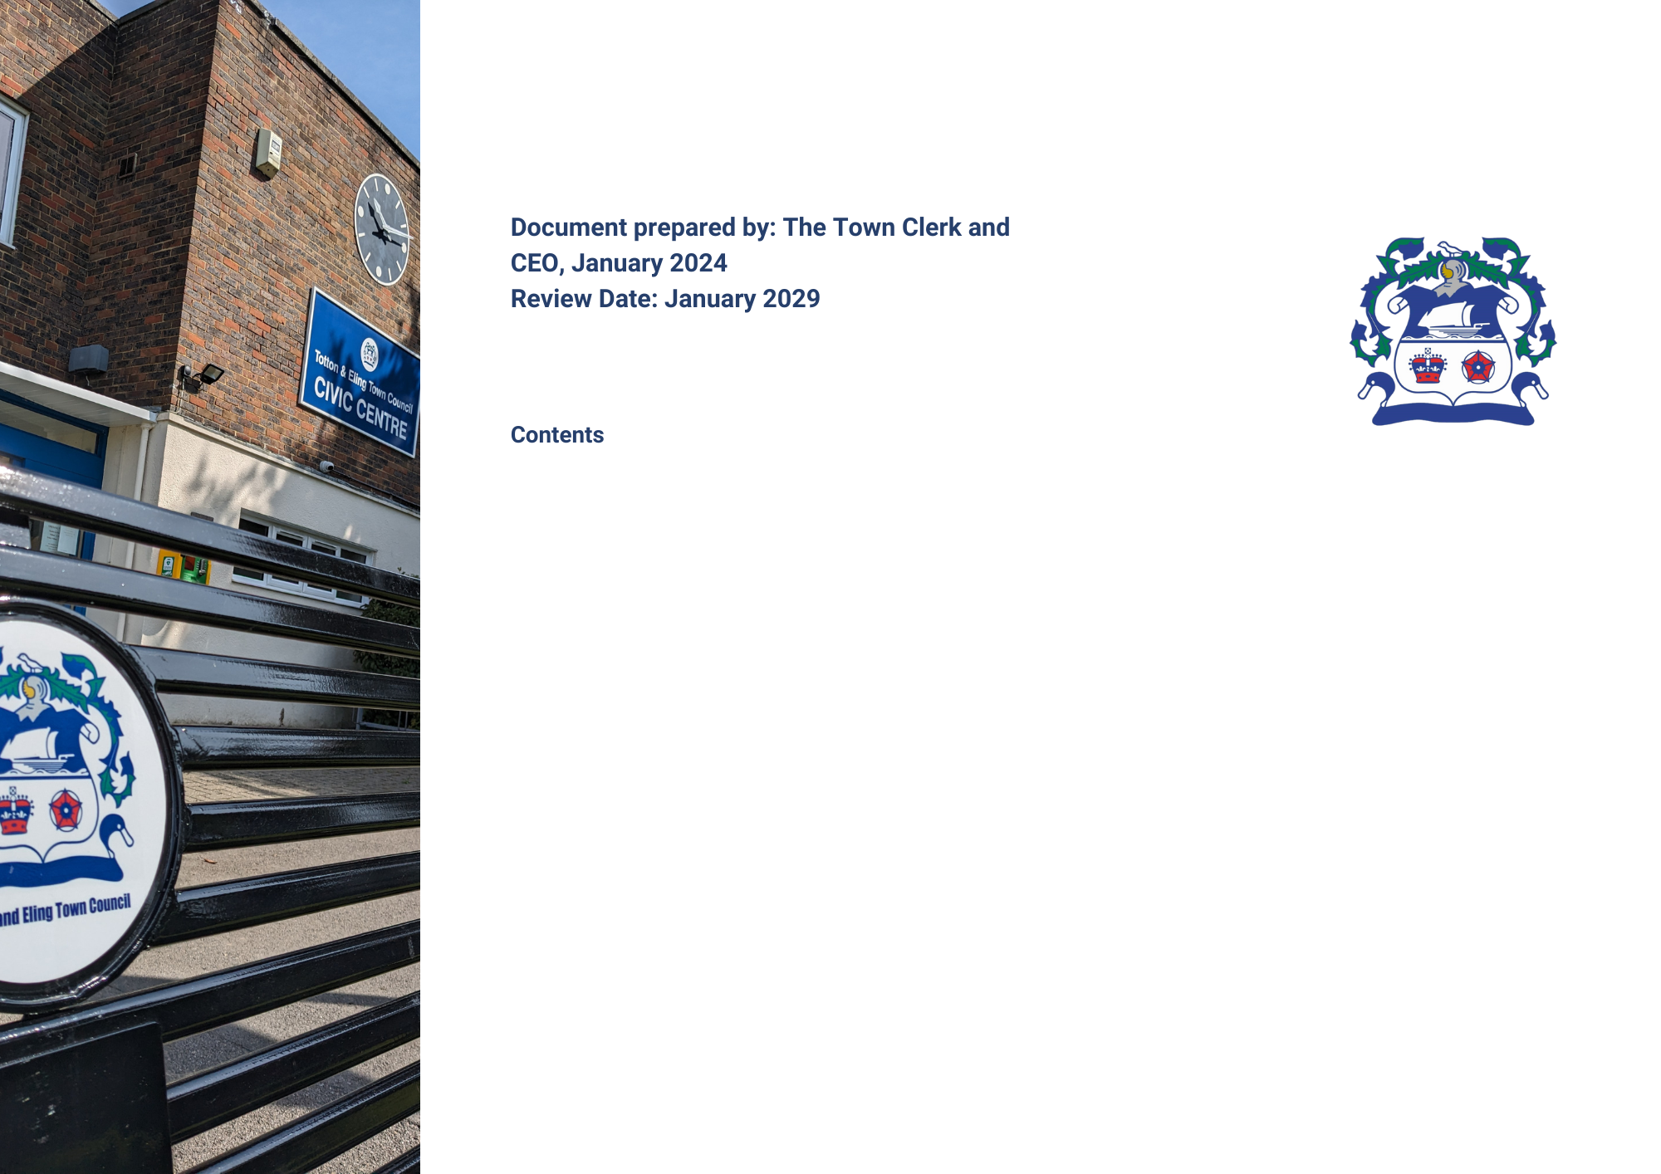

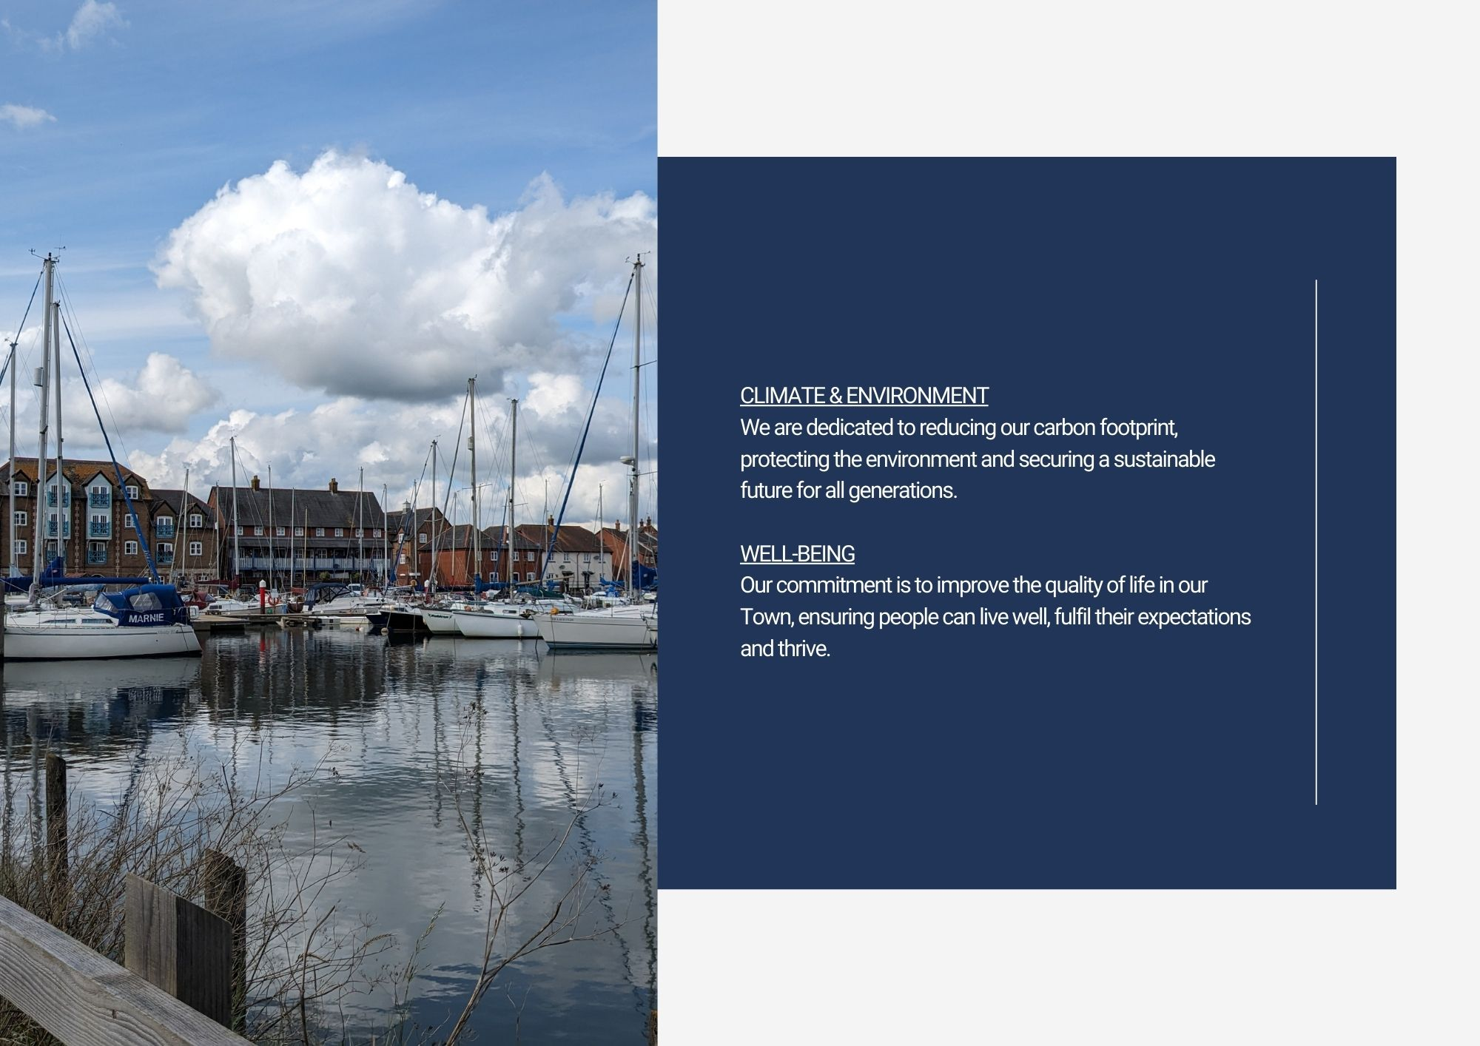

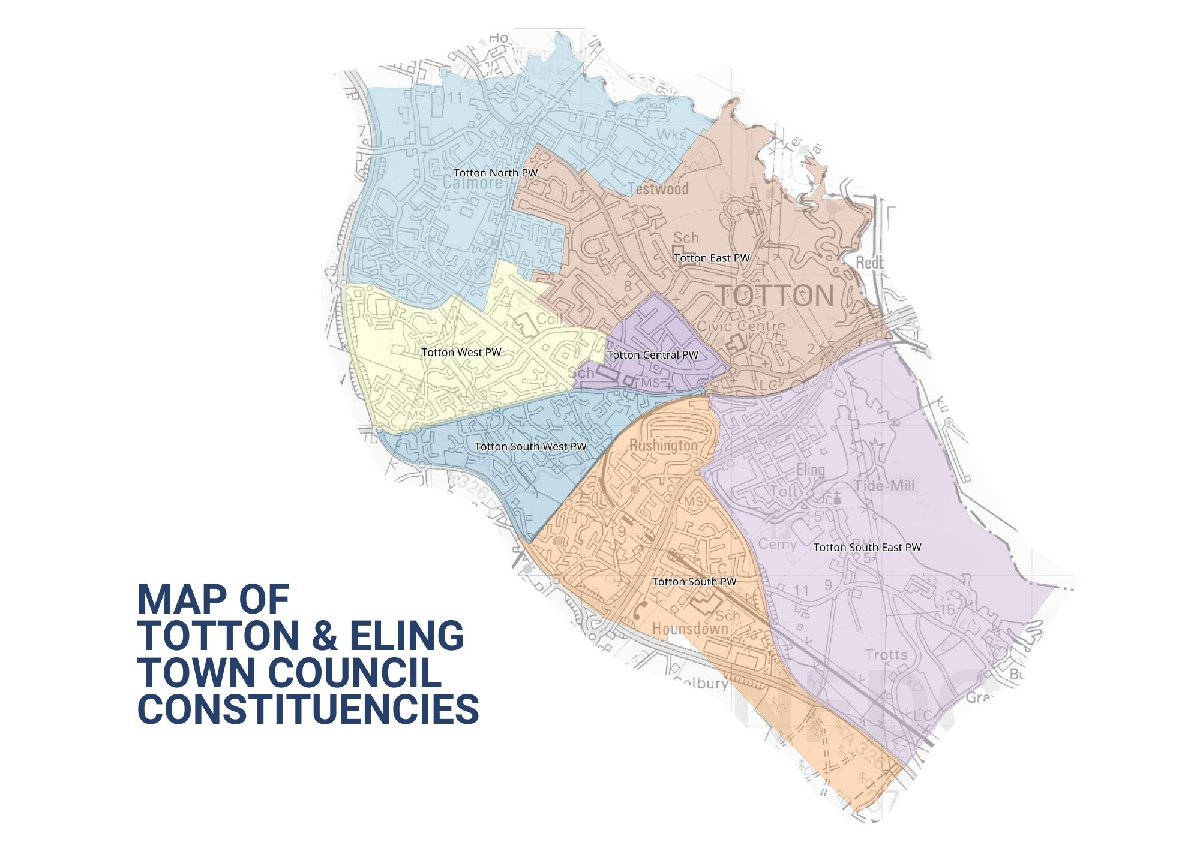

**Introduction**

Welcome to Totton and Eling Town Council. This is our Strategic Plan – it sets out what we are going to do over a rolling year period of five years and is a statement that we must be a Town Council that is relevant and responsible. The Plan takes into account the issues facing us and our ability to respond with the resources available. It makes clear there will be choices, and how the Council will decide which to prioritise.

The Plan has been approved by your Town Councillors. It is essentially a planning tool to assist us with the practical decisions we have to take when we meet bi-monthly, supported by a review process that helps us look back on our performance. By publishing our Strategic Plan, we can help those who live, work or visit the Town see what we are doing on their behalf. The Council has devised pillars or themes that will be referred to in the plan and will form the basis for the Council’s strategic aims and will comply with its code of conduct and Nolan principles, which include selflessness, integrity, objectivity, accountability, openness, honesty and leadership.

**Context**

This is our first Strategic Plan, prepared at a time of austerity across society when all organisations that provide services to the community, be they public, private or voluntary are facing cost pressures and resource restrictions. The emphasis is on value for money, efficiencies, collaboration and accepting that some things just will not get done. Through a planning process though, we can have a shared vision and direction, protect what is important and consider new ways of implementing progress. The ambitions and projects included in this plan have been approved, in principle, by the Council as areas to support and resource. All projects/ambitions, which the Council feel best meet with local needs and priorities, will be kept under review and will be amended and updated as circumstances change. The Town Council have recognised the importance of establishing a Mission statement, and set of core values, which are reflected in the plan, and which are at the heart of how we operate and conduct Council business.

Totton and Eling Town Council, as the first tier of Local Government, is uniquely situated to provide the forum for understanding and supporting the needs of this community.

It provides advocacy on behalf of its residents, uses linkages to other organisations to bring in services, or directly procures them itself. Liaison with New Forest District Council happens at all levels, and there are also association to health and social care as well.

Day-to-day, the Council will seek solutions for the community, looking for skills and volunteers to make improvements to our surroundings or bringing particular neighbourhood issues to local attention to promote a better quality of life for all.

Above all your Town Council is here to help, support and encourage. This Plan tells you how.

**The Planning Cycle**

Planning (and performance) is a continuous process of gathering and assessing information, formulating actions, *doing them*, and then reviewing performance and gathering again.

Once specific actions are agreed to deliver this Plan, they are entered on the Actions/Task Register, which is monitored at every weekly meeting by the Town Council’s Senior Leadership Team and also at monthly meetings held with the Committees Chairs.

**Association**

This plan is linked very closely to the allocation of resources – mostly financial, but people’s time and energy too. Our finance is mostly derived from the Council Tax system, which follows the financial year April to March. Our precept, or ‘demand’, placed upon the Council Tax system has to be declared by January each year, in order that New Forest District Council can calculate the overall tax collection sums for each eligible household and produce the billing required. Other income is sourced through service provision.

**Key dates**

Therefore, this Plan will be monitored and updated, allowing it to evolve as the budget is also prepared, for final precept calculations in November. The Plan cycle will run from April to March, to match the funding available, and will be reviewed at monthly Chairs of Committee and Senior Management Team meetings to assess achievements in the previous cycle, and progress in the current one.

**What is a Town Council?**

A civil Town or Parish is an independent local democratic unit for villages, Towns, and suburbs or urban areas. Each Town/Parish has a Parish (or Town) meeting consisting of all its local government electors and most (where the electorate exceeds 200) have a Parish or Town Council. Over 13 million people live in such parishes, with approximately 30,000 in the Town of Totton and Eling. The Town Council is supported by Officers employed within each service area to deliver both the Council’s services and policies, together with ensuring decisions are implemented appropriately.

The Town Council is a local authority. Its Councillors are elected for four years at a time in the same way as for other Councils. Bye-elections may be held to fill vacancies occurring between elections, or members may be co-opted onto the Council if no election is called. The Council is the corporation of its Town in the New Forest area, it covers the Town of Totton and Eling. In May each year the Councillors choose a Chairperson and Vice Chairperson from amongst their number. In Totton and Eling, there are 20 Councillors who make up the Town Council, which employs a Clerk to manage administration and the day-to-day running of the Council and its facilities. The Town Council will adhere to good governance and best practice via its adopted and published policies/procedures and act in the interests of local people in making representation.

**What can we do?**

**Powers and Duties**

Town Councils have a number of formal powers, set out in a wide range of legislation. A duty is something that a Council must do, a power is something that it may do, if it so decides. A Town Council cannot do anything that is not permitted by law.

The Town Councillors know the Town and can now (and increasingly often do) represent their views directly to other authorities like the District and County Council at its Area Boards, Health Authorities, Police and Fire Authorities meetings.

They are entitled to be consulted on planning applications, which include work to listed buildings and on proposals in conservation areas and are often consulted on such things as schools and roads. They put the Town’s case at public inquiries.

There is the power to create a Neighbourhood Plan which allows local people to get the right development for their community, but the plans must still meet the needs of the wider area.

**Accountability**

You elect its members every four years – the next time will be May 2027 – and you are entitled to attend the Annual Town meeting between March and June each year and to say what you think. You can also go to every meeting of the Town Council and meet the Council members, listen to their business, and participate during the time especially set aside for that purpose at the start. The accounts are strictly audited every year and published.

You can find out more about what we do, how we do it, and our meetings on the Town’s website at <http://www.tottoneling-tc.gov.uk>

**What do we do?**

The Town Council provides a number of direct services to the community and acts as custodian to a number of assets held in the ‘public name’ and provide the following services:

Allotments Parks & Open Spaces Outdoor paddling pools and splash park Leisure & sports facilities

Halls for Hire Public conveniences Memorials Public notice boards

Boat moorings Bus shelters Community safety warden Heritage site and café

Skate park Cycle track Town benches Walking routes

Although New Forest District Council is the Planning Authority, the Town Council is consulted on each planning application made in the Town. Councillors consider planning applications at their meetings and inform New Forest District Council of their views and recommendations.

At each meeting of the Council, reports from a variety of Town organisations are received, and Councillors seek to provide support where necessary or requested in order that local groups can continue to thrive.

Each meeting considers issues for our communities such as planning (for example, housing, change of use or tree felling) crime and community safety, facilities for all generations, or items of maintenance in the ‘public realm’ that need reporting to appropriate authorities. The Council can act as advocate for residents, a conduit for communicating information, and will liaise with appropriate departments of other public authorities to ensure that views, comments and necessary actions are dealt with.

**What we achieved in the last year**

Between 2023 and 2024, we have achieved a wide range of improvements, both to the way we work, and to the community we serve. These are listed later in this document.

**Established** policy reviews and formulation such as Equal Opportunity, Members and Officers Best Practice, Annual Leave and a General Reserves Policy are but a few actioned during 2023/24.

**Considered:** planning applications, grant applications, activities, events, legislation, projects, most of which were supported by the Council together with policies and procedures.

**What do we want to do next?**

The Town Council has worked through the Town’s Committees and Group’s findings and has developed a 5-year Strategic Plan. This plan has been built around our Mission Statement, Core Values and public consultation. As a live document it will be expanded and evolved as it develops.

The table attached sets out the Strategic Plan adopted by the Council, and which will be implemented over the next five years:

**5 YEAR PLAN**

|  |
| --- |
| **WELLBEING, HEALTH & SAFETY – Supporting life satisfaction, achievement and security.** |

|  |  |  |  |  |
| --- | --- | --- | --- | --- |
| **Ambition** | **Council Committee/**  **Department** | **Timescale** | **Success would be** | **Progress At:**  **29/01/25** |
| **Formulation of a Youth Council** | Wellbeing Group  Policy & Resources Committee | 0 – 1 year | To implement and support a well-attended Youth Council, encouraging good communications with the Council and for young people to take part in the democratic governance of the Town. | Approval given and Councillors were appointed at Full Council on 31.07.24, to converse with school Councils to gain young people’s input on projects and activities in the Town. First school visit by appointed Councillors took place in October 2024. Various ideas were discussed, including a return visit for Councillors to address the School’s Youth Council. On-going. |
| **Resident’s Forum** | Wellbeing Group  Policy & Resources Committee | 0 – 1 year | Giving residents a voice and allowing them to advise the Council of issues, and requests. Additionally, providing feedback to the public, will enhance communication, confidence and thus provide a better place to live and work. | Update from meeting in April 2024 verified that existing Residents’ Associations already have strong Council liaisons. Recommendations for a residents’ evening event have now been cancelled due to lack of support. On-going |
| **Business Forum** | Town Clerk  Wellbeing Group | 0 – 1 year | Forming a business forum will provide support to the businesses in the Town giving the opportunity for input and thus encouraging a thriving community. | Two meetings have been held resulting in some positive feed back. A business forum social media page is being investigated. The last meeting held in May was not attended by any businesses in the Town. |
| **Follow and review Town Council’s Health & Safety Policy** | Policy & Resources Committee | 0 – 5 years | Ensure the Town Council provide a legal, safe, and secure working environment for staff, Councillors, volunteers and service users. | Health & Safety annual audit was completed in March 2024. Policy was renewed in March 2024. Next due for renewal March 2025.  On-going |
| **Health & Safety/Fire training for staff** | Town Clerk  HR Department | 0 – 5 years | Recognising the importance of training being given to staff for their safety and wellbeing. | On-going H & S/Fire training courses organised for all staff. Fire drills are held on a 6 monthly basis. |
| **Expand CCTV coverage of the Town** | Amenities Committee, Policy & Resources Committee | 0 – 5 years | Provide a safer environment by supporting anti-crime and disorder within the Town, giving residents, visitors and businesses a sense of security and peace of mind. | Additional cameras in areas of the Town are being considered.  Awaiting response on feasibility studies on suggested areas. CCTV regulation course was attended by Officers in November 2024. Additional Cameras have now been agreed to be installed in Salisbury Road and Nutshalling Close in 2025. |
| **Uphold diversity, equality and inclusion within the Town** | Policy & Resources Committee | 0 – 5 years | By the introduction of improved facilities and open spaces the Town Council would reiterate and develop its commitment to working towards all individuals making use of those facilities in line with health & safety, legislation and inclusion. | Funding for this play equipment will be from SPF monies, and appropriate inclusive equipment is being sought. The project is now out for tender. |
| **IT, COMMUNICATIONS & MARKETING – Building trust, confidence and success through strengthened communication.** | | | | |

|  |  |  |  |  |
| --- | --- | --- | --- | --- |
| **Ambition** | **Council Committee/**  **Department** | **Timescale** | **Success would be** | **Progress At:**  **29/01/25** |
| **Digital play area, tree, and allotment inspections** | IT, Communications & Marketing Task & Finish Group  IT Officer | 0 – 2 years | More accurate and detailed digital inspections, would assist in identifying insurance liability responsibility, an improved Health & Safety focus and the implementation of preventative measures. | Equipment and software are presently being researched.  On-going |
| **To encourage residents to have their say, and provide input and feedback to the Council via our website and social media pages** | IT, Communications & Marketing Group.  IT Officer. | 0 – 5 years | Improvement of public participation in decision making and ideas/suggestions for facility provision and improvements for the Town. | Part of the Council’s IT improvements.  On-going |
| **Support and increase the range of information available to residents in relation to community projects, activities and services.** | IT, Communications & Marketing Group  IT Officer | 0 – 5 years | Improvement of communication channels to provide the community with up to date, and accurate information for the betterment of wellbeing, business and civic pride. | Part of the Council’s IT improvements. Links to support and aid groups will be incorporated into the new website for maximum awareness of what is on offer for residents. Groups are being added as part of the expansion of the new website and details of support/aid services are now, via a QR code, available in the Town Council Annual Report 2024/25. A marketing/events programme has now been formulated for increased communication with the community.  On-going |
| **Identification of IT opportunities** | IT, Communications & Marketing Group  IT Officer | 0 – 5 years | By monitoring and identifying up and coming IT this will enable reform and more efficient staff and Councillor operation. | Upgrades of CPU’s at the Civic Centre are required for new windows package, by October 2025 when the support for the present package ends. Costs will be evaluated via the tendering process. A present review of Microsoft licenses will allow reductions in costs. On-going. |

|  |
| --- |
| **POLICY – Assurance of compliance, best practice and values.** |

|  |  |  |  |  |
| --- | --- | --- | --- | --- |
| **Ambition** | **Council Committee/**  **Department** | **Timescale** | **Success would be** | **Progress At:**  **29/01/25** |
| **Review of fit for purpose Standing Orders, and Financial Regulations** | Policy & Resources Committee  Town Clerk | 0- 2 years | Updated, more defined and inclusive standing orders for improved governance and policy adherence. | Revised Standing Orders have been formulated for Council approval and will be finalised once the review of the Financial regulations have been completed.  On-going |
| **Review of Byelaws** | Policy & Resources Committee  public consultation, government bodies  Town Clerk | 0 – 3 years | Reformed byelaws more relevant to the provision in the Town. Improved governance and byelaw adherence. | Anticipate commencement in Summer 2026.  On-going |
| **On-going staff structure review.** | Town Clerk  Personnel Sub Committee (if applicable) | 0-5 years | Periodic review to ensure staffing structure meets business needs and requirements. | Monitoring and assessment in progress.  On-going |
| **Review of procurement Policy & procedure** | Town Clerk  Policy &Resources Committee | 0.5 years | A review of the procurement policy is required to incorporate the procurement Act 2023, which came into effect on 24th February 2025. The aim of the new legislation is to improve the opportunity for authority contracting and thus increase best value for public spending. | The policy is at present being reviewed, with guidance from Government advice. |
|  |  |  |  |  |

|  |
| --- |
| **HERITAGE, ARTS & CULTURE – preserving heritage and culture, together with Town creativity and identity.** |

|  |  |  |  |  |
| --- | --- | --- | --- | --- |
| **Ambition** | **Council Committee/**  **Department** | **Timescale** | **Success would be** | **Progress At:**  **29/01/25** |
| **Bollard painting** | Amenities Committee | 0 – 2 years | Providing individualisation and making the Town more attractive and welcoming for both residents and visitors. | War memorial bollards have already been completed. Further bollard decoration estimated throughout 2025.  On-going |
| **Provide support for arts, cultural events and activities in the Town** | Amenities Committee Policy & Resources Committee  IT Officer | 0 – 5 years | Bringing cultural/artistic awareness and education to the Town. Increasing footfall relating to events, businesses and Town facilities for communal utilisation and enjoyment. | Consideration for support of art and cultural event requests are regularly received and are welcomed by the Council.  On-going |
| **Provide Amenities for Arts and cultural performance** | Amenities Committee | 0 - 5 years | Continuance of the leasing of the Council’s Hanger Farm facility and introduction of a performance area in the Town Park, will uphold and expand the Communities’ exposure to, and enjoyment of, Arts and Culture in the Town. | Continuance of support for Arts and Cultural performance is through the Hanger Farm Arts Centre, via Arts Festival aid and promotion of this stunning facility.  Meetings with Hanger Farm Arts Centre are held on a 6 monthly basis.  On-going |
| **Support continuation and improvement of the Eling Tide Mill Experience and to promote local historical interest** | Amenities Committee | 0 – 5 years | The Council’s preservation, support and funding of this prime heritage site will ensure the provision to local residents and visitors offering the continued opportunity to enjoy this unique historical site. | The Tide Mill is undergoing repairs. The café and visitors centre are now open for 5 days per week during the winter months and events and funding are being applied to the experience as a whole throughout the year to encourage more visitors to this worthy venue. Meetings are being held with the landlord in relation to improvements to Eling slipway area. Repairs to the Quay side and bridge will commence in April 2025 for approximately 7 weeks. Eel passage being installed 17th February, taking approximately 2 weeks.  On-going |

|  |
| --- |
| **INFRASTRUCTURE – Striving for improved accessibility, enabling better community interaction.** |

|  |  |  |  |  |
| --- | --- | --- | --- | --- |
| **Ambition** | **Council Committee/**  **Department** | **Timescale** | **Success would be** | **Progress At:**  **29/01/25** |
| **Better Road infrastructure in the Town Centre, with**  **more accessibility for cyclists and walkers** | Planning Committee | 0 – 5 years | The Council wish to instigate a walking & cycling transformation in the Town Centre which would allow better access, numerous health benefits, greener travel and road safety; subsequently promoting increased wellbeing and equity. | The Town Council are liaising with the County and District Council formulating a partnership which will progress the reform of the Town Centre infrastructure. A further meeting was held in July to discuss the formulation of a masterplan framework which was presented and approved at Full Council on 31.07.24. Next partnership meeting is scheduled for late 2024. Further discussions on the proposed LCWIP waterside document and the ‘barriers to walking and cycling’ survey will be held at the Planning meeting in December 2024.  On-going |
| **Better access to public transport** | Planning Committee | 0 – 5 years | Better public transport would provide people with access to essential services, employment and improved social integration. Additionally, it will reduce congestion and air pollution and offer a more affordable transport option. | The Council have an objective to work toward increasing the public transport in the Town to develop better quality community and equitable mobility.  On-going |
| **Increased and improved long term free parking in the Town** | Planning Committee | 0 – 5 years | More available long term free parking would produce increased foot traffic, a strengthened local economy, together with attracting more visitors and improved accessibility to public services, recreational facilities and health care. | The Planning Committee are examining options to improve the long-term free parking in the Town, which will not only improve the versatility of parking choices but assist in eliminating on-street parking issues for residents. Work is proceeding with the District Council for assistance in delivering better parking. A letter of objection to the increased parking and parking clock charges was sent to NFDC from the Town Council in December 2023. A petition from residents objecting to the parking fees/clock charges has been collated and was sent to the District Council for consideration in mid- February 2024. The District Council have asked for consultation on a proposed District wide car parking strategy from residents, businesses and partnerships in the New Forest area for completion in approximately May 2025. This will be formulated via three phases, with the first two by 1st December 2024, and later in regard to a draft proposal in approximately February 2025. On-going |

|  |
| --- |
| **GOVERNANCE, VISION AND STRATEGY – allowing evolved suggestion, inspiration, and measure of success.** |

|  |  |  |  |  |
| --- | --- | --- | --- | --- |
| **Ambition** | **Council Committee/**  **Department** | **Timescale** | **Success would be** | **Progress At:**  **29/01/25** |
| **Digital recording of meetings** | IT, Communications & Marketing Group  IT, Communications and Marketing Officer | 0-2 years | Digital recording of meetings will enable better transparency and improved community involvement in the Council’s governance. | The Town Council approved a Recording, Photography and use of Social Media at Meetings policy in September 2023. Progression to visual meeting recordings is in incorporated in the Council’s IT improvements.  On-going |
| **Improve the image of and pride within the Town, making it more attractive for residents, visitors and businesses** | Communications & Marketing Group Amenities Committee | 0 – 5 years | Ensuring a more positive image and individual character will help us reinvent the Town and boost retail, leisure and events for community participation. Town pride provides community focus and is a critical part of communal betterment of welfare. | The Town Council have formulated a Wellbeing group which is centred on improvement of Town pride, thus encouraging volunteers and groups to support activities for the common good of the Town’s population. Budgets and intensity of planting in the Town has increased, and plans for a community health bus are being discussed between local Parish/Town Councils, but will be dependent on obtaining funding.  On-going |
| **Continue to improve relationships between Councillors and Officers** | Town Clerk | 0 – 5 years | Improved communication between both Officers and Councillors will enhance unity in both the decision making and day-to-day running of the Council services, together with more effective communication to the community. | Monthly meetings with the Chairs of Committees and Senior Management occur where discussion permits communication and builds positive relationship between Officers and Councillors. This in turn aids the monitoring of projects, their deliverance and best value application.  Regular meetings of Officers and Councillors are organised throughout the year; a successful relationship session was held in November 2024.  On-going |
| **On-going staff structure review** | Town Clerk  Personnel Sub committee (if applicable) | 0-5 years | Periodic review to ensure staffing structure meets business needs and requirements. | Weekly meetings of the Senior Leadership Team assess workloads and monitor performance to establish sufficient staffing levels. Relevant role evaluations are implemented, as required.  Some job evaluations required after recent annual appraisals. Commencing in late May 2024. Evaluations have now been completed. Next annual appraisals are to be held in March 2025.  On-going |
| **Ensure adequate level of insurance for Town Council facilities and assets** | Town Clerk  RFO | 0 – 5 years | Annual review of facility and asset insurance, together with public liability and indemnity will ensure the Council is adequately insured against claim, damage or obligation. | Regular reviews and stringent monitoring of claims and asset values  assure sufficient cover is in place at all times. Best value quotes are sought at time of renewal. Renewal of insurance has now been approved for 3 years.  On-going |
| **Development of a Neighbourhood Plan** | Planning Committee | 0-2 years | The Town’s Neighbourhood Plan is almost complete and is in preparation for consultation. The Neighbourhood Plan has given, and offers, further opportunities for residents to have a voice in the future of the Town for inclusion; this also portrays the importance of local needs and desires. Completion of the plan will also allow increased funding payable to the Council in regard to CIL monies from 15% to 25%. | Regular meetings have been held to progress the Neighbourhood Plan. Documentation and evidence is being collated for the submission of a draft plan to the District Council, in order for consultation. |

|  |
| --- |
| **PLANNING – Empowering community views and the development of our Town.** |

|  |  |  |  |  |
| --- | --- | --- | --- | --- |
| **Ambition** | **Council Committee/**  **Department** | **Timescale** | **Success would be** | **Progress At:**  **29/01/25** |
| **Planning applications consideration**  Planning & Development Act 2024 | Planning Committee  Planning Committee | 0 – 5 years  0 1 year | Although the Town Council is not the planning authority, deliberation and the opportunity to provide local views and reflections is paramount. These permit the projection of the communities’ thoughts, opinions and goals for what is being built, converted or situated in our Town. | Applications are considered by the Planning Committee on the first Wednesday of every month. Meeting dates are published on the Town Council’s website for attendance. An amendment to Section D, 4.3 of the planning delegation was approved and recommended at the Policy & Resources Committee meeting on 17th July 2024. New regulations in regard to Planning & Development are expected to be instigated shortly. Training has been arranged for Officers to adhere to the new regulations. |

|  |
| --- |
| **EVENTS – Building a sense of community spirit, social interaction and celebration of what is good in the Town.** |

|  |  |  |  |  |
| --- | --- | --- | --- | --- |
| **Ambition** | **Council Committee/**  **Department** | **Timescale** | **Success would be** | **Progress At:**  **29/01/25** |
| **Introduction of Town Market** | The Town Council | 0 – 1 year | By introducing a Town market this will provide the capacity to revitalise the Town and act as a communal pillar fostering community spirit and produce a unique local business experience. | Funding approved to commence this event. Markets have been held in August, September and October 2024. These proved to be very successful. It is envisaged that expansion of the market will be on-going through promotion of the market to both residents and stall holders. All market dates can be viewed on the Council’s website. Market dates for 2025, are being confirmed, as too are road closures and budgets. The next Town Market will be held in March 2025.  On-going |
| **Continual support of Remembrance Day and Armistice Day** | The Town Council | 0 – 5 years | The continuation and importance of these popular and well attended events which give the Town the opportunity to pay tribute to the people who made sacrifices in times of war, is paramount. Assistance in funding these events is an honourable, respectful and significant commitment of the Town Council and a provision for this and future generations. | The Town Council provide funding for both the Remembrance Day and Armistice Day events and have budgeted to do so for the forthcoming year.  Events are being organised for funding by the Council in regard to VE & VJ 80th anniversary celebratory events.  On-going |
| **To encourage community initiatives to use the Towns facilities to create events, festivals, fetes, exhibitions, pop-up businesses and groups** | Amenities Committee  IT, Communications & Marketing Group | 0- 5 years | Provision of more events in the Town to promote improved wellbeing, social interaction and higher footfall to the Town area for businesses. | The Town Council annually license their land for events such as the Donkey Derby, Carnival, Fundays and sporting events. The Town Council will continue to make their land accessible for community events and consideration of all events are welcomed and supported wherever possible. The Donkey Derby has proven to be successful once again, as too was the Carnival. The Lantern Parade was held in December 2024, and was very well enjoyed and attended.  On-going |
| **Create and manage an events page on the Town Council’s website** | IT, Communications & Marketing group.  IT Officer | 0 – 5 years | To attract larger numbers of people to support events within the Town and tackle social isolation. | Community events will be integrated onto our events page of the new website. This will improve awareness and promote involvement. This page is part of the expansion to the new website which was launched in April 2024. Events are published on the new web site regularly and the newly formulated marketing/events programme will enhance communication with the community.  On-going |
| **To assist and support the Twinning Association with the Town twinning of Trittau in Germany and Communaute de Communes Loire Divatte in France.** | Town Council | 0 – 5 years | The Town Council wish to continue twinning with Trittau in Germany and Communaute de Communes Loire Divatte in France to further enable the formation of cultural and social links. It recognises the importance of association between two similar communities which, through exchange visits, builds relationships and educates in regard to other traditional lifestyles. | On-going support for the Twinning Association will ensure the continuity of good relations and ties with Totton & Eling Town Council, Trittau in Germany and Communaute de Communes Loire Divatte in France. A trip to Communaute de Communes Loire Divatte is planned for June 2024.  Additionally, 18 visitors from Trittau in Germany arrived in Totton in August 2024, for a 5-day visit to the Town.  On-going |
| **To commemorate the 80th anniversary of VE day**  **To commemorate the 80th anniversary of VJ day** | Town Council  Royal British Legion  Town Council  Royal British Legion | 0-1 year  0-1 year | The Town Council approved the funding of celebrations and commemorative activities for the 80th Anniversary of VE day in January 2025. Events will include a memorial service, flying of commemorative flags, lights of peace parade, street party, theatrical performance, singing in the park and Tea Dance.  The Town Council approved the funding of celebrations and commemorative activities for the 80th Anniversary of VJ day in January 2025. Events will include a memorial service, flying of commemorative flags, lights of peace parade, planting of trees and bushes, theatrical performance and bench memorial. | Organisation of events are going well and on schedule.  The events will give the public the opportunity to mark this great day of peace by attending and participating in all the planned activities in the Town over the four days from 8th May – 11th May 2025.  On-going.  Organisation of events are going well and on schedule.  The events will give the public the opportunity to mark this great day of peace by attending and participating in all the planned procedures in the Town and enjoying the commemorative facilities.  On-going. |
| **FINANCIAL – Managing the Council’s finances through best value and transparency, thus successfully funding the resources needed to provide local public services.** | | | | |

|  |  |  |  |  |
| --- | --- | --- | --- | --- |
| **Ambition** | **Council Committee/**  **Department** | **Timescale** | **Success would be** | **Progress At:**  **29/01/25** |
| **Continue to comply with legislation to ensure the provision of accurate accounts and records** | Policy & Resources Committee  Responsible Finance Officer | 0 – 5 years | By ensuring the Council meet with advice from auditors, and operation within audit and statutory regulation, the provision of accurate, compliant and transparent accounts can continue to be produced. | The Council have financial regulations in place. Both internal and external audits are carried out on an annual basis. Weekly Senior Leadership Team meetings monitor accounts and assess budgetary conformance. Bi-monthly Policy & Resources meetings receive reports on actual figures against budget, accounts are published for transparency and continuation of all statutory and best practice procedures will remain. Internal audit has now been completed and Council approved in March 2024. The external audit is now completed and was noted by Council in September 2024. The next audit is scheduled for March 2025. |
| **Spending of £136,200 allocation of regeneration monies within timescale** | Policy & Resources Committee  Town Clerk  Officers | 0 – 1.5 years | The Council have been awarded £136,200 in Shared Prosperity Funding monies. This funding will give the Town Council the capability to progress the Town’s regeneration and provide better social, economic and environmental facilities for the community. | Projects for these monies have been agreed by the Council and will be implemented by Officers in line with allocated budgets and time bound periods. Projects will be updated in the facilities section on this document, and moved to the achieved section when completed. Agreement for the monies has now been signed. Projects have been commenced and are regularly monitored for progression and spend. All projects are on schedule for completion by the deadline of March 2025.  On-going |
| **Spending of earmarked and additional CIL monies with timescale** | Policy & Resources Committee  Town Clerk  Officers | 0 – 5 years  0 – 2 years | Responsibly deploying Community Infrastructure levy monies will establish and confirm prudent funding of improvements to facilities and areas of the Town identified in this plan. | A broad range of facilities are already supported by CIL monies. The Council have agreed, in principle, future projects to be funded by earmarked CIL monies, and these are scheduled for delivery over the next 5 years. No additional CIL monies have been awarded for 2024. Bids have been submitted for funding opportunities from the District Council for January 2025.  On-going |
| **To continue to support local charity and voluntary support groups eligible for funding via the grant system** | Policy & Resources Committee | 0 – 5 years | Continuation of grant support to local groups and charities will enable existing and future support organisations to provide services to people in need of help in the Town. | The amended grants policy was approved in January 2024, and now gives organisations the opportunity to claim up to twice a year for a maximum of £3,000 per annum.  On-going |
| **Maintain adequate reserves** | Policy & Resources Committee  Town Council | 0 – 5 years | Retention of adequate reserves, as advised by audit will ensure the Council remains financially buoyant, functional and able to produce healthy accounts. Annual review of reserves monies will monitor and ensure correct reserves are kept. | The Reserves policy was reviewed and recommended by the Policy & Resources Committee on 17th July 2024, and passed by Full Council on 31.07.24  On-going |

|  |
| --- |
| **CLIMATE & NATURE - Helping to create and maintain a sustainable carbon neutral environment** |

|  |  |  |  |  |
| --- | --- | --- | --- | --- |
| **Ambition** | **Council Committee/**  **Department** | **Timescale** | **Success would be** | **Progress At:**  **29/01/25** |
| **The Town Council aim to be carbon neutral by 2040** | Climate & Nature Group  Policy & Resources Committee | 0 – 5 years | Monitoring of Council operations, recycling, and environmental improvements will help us to achieve our reduction in carbon footprint. | A Climate and Nature action plan has been formulated and will be reviewed by the Climate & Nature Change Group regularly.  The Town Council declared a Climate & Nature emergency and both Climate & Nature action plans were approved by Full Council on 31st January 2024. The plans will be updated on a bi-monthly basis by the Town Clerk and are available to view on the Council’s website. The Great Collaboration Toolkit for residents and businesses is now linked to the Council’s Climate change page shortly, to aid in addressing carbon reduction in the Town. Next meeting scheduled for December 2024. The Town’s carbon footprint report produced by the centre of sustainable energy, shows positive reductions from last year’s, with the Town being below the UK average in regard to omissions for the majority of sectors.  On-going |
| **Reduction of energy and fuel consumption across Council facilities, operations and services.** | Climate & Nature Group  Policy & Resources Committee | 0 – 5 years | By using green energy providers and the reduction of fuel in Council vehicles this will demonstrate a positive path towards a reduced carbon footprint. | All energy companies used by the Council offer reuseable energy.  3 Maintenance vehicles have now been replaced with electric vehicles. Staff have been given instruction on reduction of energy on day-to-day utilities use. A Thermal imaging survey will be implemented at the Town Council’s facilities during the first quarter of 2025 for the identification of energy reduction. |
| **Reduce Waste, increase recycling, reduce disposal options etc** | Climate & Nature Group Amenities  Policy & Resources Committee | 0 – 5 years | Working towards a reduction in all waste products, increased recycling and improvement of disposal options would assist towards the reduction of the Council’s carbon footprint.t | The Council are looking at various alternatives to reduce waste including the reduction of single use plastics, avoidance of plastic packaging and utensils.  On-going |
| **To promote education with regard to biodiversity and create a re-wilding programme.** | Climate & Nature Group  Volunteers  Amenities Committee  Policy & Resources Committee | 0 – 5 years | To promote biodiversity and the formulation of a re-wilding programme will assist in wildlife travel, enhancement and future development in the Town. | All Council green waste is environmentally disposed of via registered green waste routes and put back into the horticultural environment. Volunteer survey taking place for data and observation for inclusion in the wilding programme. Staff had attended nature recovery workshops.  On-going |
| **Maintain and protect current trees and increase Tree Planting in the Town** | Climate & Nature Group  Amenities Committee  Policy & Resources Committee | 0 – 5 years | Increasing provision in addition to the 17,000 trees presently owned and maintained by the Council will assist in the offset of carbon. Additionally, this will offer natural shade and shelter for residents and wildlife. | Regular tree inspections are carried out for both  tree/property protection and carbon reduction.  Successful bid to expand the Community Orchard at Bartley Park funded through HCC scheme was confirmed in February 2024. Funding for additional tree planting at Bartley Park will also provide stabilisation for a bank area, and provision of a wildlife corridor. Planting of additional trees is complete. Funding has been identified for more tree planting for 2025, and a further 21 trees have now been planted at Eling Quay and other areas in the Town.  On-going |
| **Reduction of pollution** | Climate & Nature Group  Amenities Committee  Policy & Resources Committee | 0 – 5 years | By using natural noise reduction screens, regular litter picking and reduction in use of pesticides, the Council can assist in reducing pollution and the protection of nature in the Town and surrounding areas. Additionally, more cycling and walking facilities will assist in pollution reduction. | The Town’s infrastructure is being addressed. Liaison with both the County and District Councils in regard to increasing accessibility for cycling or walking have commenced to discuss plans to decrease vehicle movement in the Town and thus aid in the reduction of pollution. Vehicle fleet policy approved March 2024 to enhance the Council’s responsibility to carbon reduction.  On-going |
| **Emergency Flood Plan Formulation and prevention actions** | Climate & Nature Group  Amenities Committee  Policy & Resources Committee | 0-2 years | Formulation of an Emergency Flood plan and advice on prevention actions will assist residents and businesses in regard to available support and aid. | Quick Win support is being implemented, where possible, through Flood Plan information packs issued to affected residents. Funding implementation investigation for further flood deterrent equipment and support is being sought. Through Council enquiry, steps are now being taken to provide additional protection for the sub-station at Eling to reduce the impact of flooding on electricity for residents. A flood plan was approved by Council in September 2024, and is now on the Council’s website for information. |
| **Bird and Bat boxes**  **Bug Hotels** | Climate & Nature Group  Amenities Committee | 0-1 year | The introduction of Bird and Bat Boxes, together with bug hotels will assist in nature travel in the Town, and the facilitation of habitats which will aid in the growth of population of these species. | Discussions with District Ecologist being held to ascertain preferred locations for boxes and hotels. Some Bat boxes and insect hotels are being donated to schools in the Town for inclusion in their curriculum with regard to nature education. |

|  |
| --- |
| **FACILITIES - Provide, and maintain accessible, inclusive and sustainable facilities to promote community enjoyment**  **for all.** |

|  |  |  |  |  |
| --- | --- | --- | --- | --- |
| **Ambition** | **Council Committee/**  **Department** | **Timescale** | **Success/benefit** | **Progress at: 29/01/25** |
| **Town Council to only implement facilities which it can adequately maintain** | Amenities Committee  Policy & Resources Committee | 0 – 5 years | By making certain that adequate revenue monies are budgeted for each year, the Council’s present and future facilities/assets will be maintained to a satisfactory and compliant level. | All facilities have regular inspection to ensure safety and enjoyment of use. Budgets are annually reviewed to ascertain sufficient maintenance funding.  On-going |
| **Introduction of more inclusive play area equipment** | Amenities Committee  Policy & Resources Committee  Officers | 0 – 2 years | Inclusive play equipment aids the level of interaction in the playground and builds self-esteem and confidence due to the removal of restriction.  This awards play opportunities for all children regardless of disability or background. | Funding has been obtained for additional inclusive play equipment at several sites in and around the Town and will be installed over the next year.  On-going |
| **Introduction of play equipment along the green route** | Amenities Committee  Policy & Resources Committee  Officers | 0 – 2 years | Placing play equipment along the green route will offer benefits to children by way of interacting with their environment, learning from nature and development through play. | Funding has been received for the introduction of play equipment along the green route to entertain and educate children on route to the Town Centre.  Designs for play equipment were approved by the Full Council Committee on 31st July 2024. Designs have been approved and instruction given for manufacture. Installation anticipated for mid to late March 2025.On-going |
| **Café in the Park** | Amenities Committee  Policy & Resources Committee  Officers | 0-1 year | A café in the park will permit elevated use of the park area in the summer months, thus promoting community engagement and culinary enjoyment for both residents, workers and visitors to the Town. | This project has been approved by Council. Unfortunately, interest in this project has been disappointing. This project has now been postponed until next Summer. Possible interest for 2025 being investigated.  On-going |
|  |  |  |  |  |
|  |  |  |  |  |
| **‘You are here’ signage for the green route** | Amenities Committee  Policy & Resources Committee  Officers | 0 – 3 years | The green route offers great access for walking and cycling in and around the Town via a number of paths. It is felt that the area would benefit from on-the-ground route maps showing the various routes available for improvement of information, and maximum utilisation for public enjoyment. | Funding has been requested for this project, and it is anticipated that signs will be installed by June 2025, should financial aid be given. An additional scheme is being investigated for the signs provision and a workshop was held in July relating to plans, and were noted. Funding confirmation from NFDC has been received and designs/locations agreed.  On-going |
| **Eling recreation ground toilet refurbishment** | Amenities Committee  Policy & Resources Committee  Officers | 0 – 3 years | The toilets at the recreation ground are in need of repair and refurbishment. Funding has been applied for to carry out these works, and should we receive the necessary award, works will hopefully be completed in time for the summer season, when they are very much used in conjunction with the splash park and other recreational activities. | Funding has been allocated from CIL monies for the Eling recreational ground toilets, and should be completed in 2025.  On-going |
| **Digital information system for Civic Centre** | Amenities Committee  Policy & Resources Committee  Officers | 0 – 1 year | Digital information provision at the Civic Centre will allow awareness of public services, an increase in transparency and a build in trust. This service will offer the public the ability to learn about community events, support groups and Council services available during visits to the Civic Centre. | Bid for possible funding has been submitted for consideration in January 2025.  On-going |
| **Town Map on the Civic Green** | Amenities Committee  Policy & Resources Committee  Officers | 0 - 1 year | An artistic and fun Town map will show opportunities to promote both recreational and keep-fit options, support local businesses/ attractions and improve vibrancy of the Town. | Bid for possible funding has been submitted for consideration in January 2025.  On-going |
| **Electric Charging points at Council facilities in the Town** | Amenities Committee  Policy & Resources Committee  Officers | 0 – 2 years | Funding has been requisitioned to provide electric charging points at the Town Council’s facilities for the public’s convenience. Additionally, this will help reduce the Council’s carbon footprint thus addressing the Council’s Climate emergency. | Bid for possible funding has been submitted for consideration in January 2025  On-going |
| **Pétanque Court at Calmore Community Centre** | Amenities Committee  Policy & Resources Committee  Officers | 0 – 2 years | Funding has been applied for to provide a Pétanque court at Calmore Community Centre. The installation of this facility will promote community,  interactivity, together with health and wellbeing benefits for people of all ages and abilities. | Possible funding available from the District Council. Costs being evaluated; on completion the tendering process will commence.  On going |
| **Continue with the provision of maintained open spaces and parks in the Town** | Amenities Committee  Policy & Resources Committee  Officers | 0 – 5 years | By continuing with the high standard of maintenance in the parks and open spaces, this will increase the opportunity for use of these areas and encourage environmentally friendly composting and cutting waste removal. | Open spaces and parks are maintained via regular best value contracts. The Council will continue to maintain these areas to a satisfactory standard and in-keeping with the environmental area for community pleasure.  On-going |
| **Continue with the provision of two paddling pools and one splash park in the Town** | Amenities Committee  Policy & Resources Committee  Officers | 0 – 5 years | By proceeding with the delivery of all 3 water facilities in the Town, this will enable residents and visitors to utilise these very popular attributes throughout the summer months. | All water facilities are repaired and prepared annually prior to opening in May. During the season they are treated to meet safety regulation and kept in satisfactory useable condition, until closure in September of each year. The Council plan to continue with the provision of all three water facilities. On-going. |
| **Town Park Play Equipment** | Amenities Committee  Policy & Resources Committee  Officers | 0 – 1.5 years | Introduction of play areas has a proven positive impact on children’s physical, social and imaginative development. Further instigation of more play areas will enhance and increase availability of play for children in the Town. | Play areas are regularly inspected for safety and regulation purpose. The Town Council aim to continue the provision of its 24 play areas in the Town and play equipment is to be installed in the Town Park by March 2025. Designs, in principle, were approved by the Town Council in July 2024. On-going manufacture, installation anticipated for March 2025.  On-going |
| **Continued provision of allotments to meet local demand** | Amenities Committee  Policy & Resources Committee  Officers | 0 – 5 years | Continuing with the Town Council’s delivery of allotments will allow residents to improve their recreational activity and grow their own food. | Allotment inspections are carried out on a regular basis to ensure adequate and appropriate use. The Town Council provide 369 allotment plots over 4 sites, and will proceed with the provision of allotments for community use.  On-going |
| **Continued provision of the Garage Youth Centre** | Amenities Committee  Policy & Resources Committee | 0 - 5 years | Giving young adults and children the option to take part in recreational and cultural activities thus developing their social skills. | The Town Council have budgeted for the continued provision of Youth Services at the Garage Youth Centre for 2024/25. Bi-annual meetings are held with the provision organisation, and a presentation was given to the Amenities Committee on 10th July 2024. Last meeting held in October 2024. Budgets have been agreed for 2025/26. On-going |
| **Introduction and maintenance of community Notice Boards in the Town** | Amenities Committee  Policy & Resources Committee  Officers | 0-2 years | Providing new community notice boards in key locations throughout the Town will improve publicization of Town Council and community facilities/activities. | Funding has been awarded for additional notice boards to be installed in and around the Town. Designs for approval presented and agreed at Full Council meeting in July 2024; tenders received; instructions given for manufacture. Installation should commence in March 2025.  On-going |
| **Continued provision of outdoor fitness equipment** | Amenities Committee  Policy & Resources Committee | 0 -5 years | Continuance of these facilities assist in helping reduce stress and encourage healthy behaviours. | The Council is committed to the provision of outdoor fitness equipment to aid in public welfare. On-going |
| **Introduction of bespoke Benches in the Town Park** | Amenities Committee  Policy & Resources Committee | 0-1 year | The introduction of bespoke benches will give the town individualisation, and be unique to totton & Eling. | Designs for approval were given by the Full Council in July 2024. Tenders received, instruction for manufacture given. Installation anticipated for March 2025. On-going |
| **To introduce bespoke litter and dog bins in the Town and surrounding area** | Amenities Committee  Policy & Resources Committee  Officers | 0 – 2 years | Improvement of bin provision in the Town will help improve the Town’s appearance, and environmental status. Locations of all bins will be shown on the new website when completed. | Funding for this project was not awarded. Alternative funding being sought. On-going |
| **Sustain the provision of public toilets in the Town** | Amenities Committee  Policy & Resources Committee  Officers | 0 - 5 years | Continuity in the provision of toilets will provide clean and safe toilets for public use. | The Town Council have budgeted for the continued provision of public toilets in the Town, and strive to provide clean and satisfactorily maintained toilets for public use. On-going |
| **Introduce additional lockable cycle racks in the Town** | Amenities Committee  Policy & Resources Committee  Offices | 0-1 year | Provision of further lockable cycle racks in the Town will encourage accessibility for cycling/walking in the Town and aid in the reduction of the Town’s carbon footprint. | Costs and locations are being sought. Taken to Committee for approval in January 2025; item, and further designs/systems being brought back to Committee when funding stream is established. |

**ACHIEVEMENTS 2024 – 2025(December 2024– December 2025)**

|  |  |  |
| --- | --- | --- |
| **Achievement** | **Details** | **Benefit to Community** |
| **Governance:** |  |  |
| **Financial:** |  |  |
| **Policy:**   * **Unauthorised Encampment Policy & Procedure** * **Community Engagement Statement** | The unauthorised Encampment Policy & procedure was approved by the Council in January 2025.  The Community Engagement Statement was approved by the Town Council in January 2025. | This Policy & Procedure will assist Officers in ensuring a defined and fair manner which follows legal process. It will also assist in the public understanding the legal process and the various stages that must be followed.  Formulation of this policy will further aid and support precise advice and speedy procedure with regard to unauthorised encampments on Town Council land.  The Community Engagement Statement shows the Town Council’s commitment to increase community engagement, thus creating more interest and empowerment for the public in having their say relating to decision making. Additionally it will clarify the Council’s intention to inform, consult and involve the Community regarding gaining a public perspective for what’s best for the Town. |
| **Facilities:**   * **Refurbishment of Town Park rockery & waterfall** * **Introduction of performance area and human sundial in the Town Park** | Improvements have been made to the rockery and waterfall area by way of overgrowth and weed removal, cleansing of the ponds and expansion of the bridge. Planting on and around the rockery will be completed by April 2025 together with lighting to illuminate the facility in the evenings.  The introduction of a performance area and human sundial in the Town Park area has now been completed. This facility can be used for dual purpose, and was funded via SPF monies granted to the Council. | The Rockery and ponds in the Park have always been a very popular facility in the Town. Cleansing of the ponds, together with the removal of the weeds will allow better wildlife sustainability and will aesthetically enhance the enjoyment for the public promoting improved wellbeing and relaxation.  The introduction of a performance area in the Town Park will allow summer arts and cultural events to take place and be enjoyed by all the community. Additionally, the area can be used as a human sundial providing entertainment, fun and learning for all generations. |
| **Events:** | . |  |
| **Wellbeing and Health & Safety:** |  |  |
| **Planning:** |  |  |
| **IT, Communications & Marketing:** |  |  |
| **Nature & Environment:**   * **Civic Award for Friends of Bartley Park Group** * **Tree planting** | An award for the Friends of Bartley park Group was given by the Town Council in January 2025.  A further 21 trees have been planted at Eling Quay  And other areas in the Town. | This award aid in the acknowledgement of volunteer groups for all their hard work and contribution to the Town’s facilities and its Open Spaces. This show of thanks and appreciation assists in the encouragement of more volunteers to help improve the Town, thus making it a better place to live, work and visit.  The continued planting of trees in the Town, enhances nature enjoyment and wellbeing, together with species sustainability. |
| **Grants:**  **The following grants have been awarded.**   * **Citizens Advice Bureau** | £3,000 was awarded to the CAB in January 2025, for support to continue running this essential service. | This grant will support the continuation of this very important and much used provision in the Town. |

**ACHIEVEMENTS 2023 – 2024 (December 2023– December 2024)**

|  |  |  |
| --- | --- | --- |
| **Achievement** | **Details** | **Benefit to Community** |
| **Governance:**   * **Create Town Council Core Values** * **Create Town Council Mission Statement** * **Create Town Council 5-year strategy plan** | Following a management review, it was identified that the Town Council would benefit from the creation of Core values moving forward.  Following a management review, it was identified that the Town Council would benefit from the creation of a Mission Statement moving forward.  The 5-year strategy plan will be a live document and thus will be amended on a weekly basis, with further updates provided by the Town Clerk via monthly Chair of Committee meetings, bi-monthly Full Council meetings, together with a monthly updated version placed onto the Council’s website for public information. | Setting of the Town Council’s Core Values will allow the alignment of our policies, procedures and operations to these values. It will also provide an important base and guidance for improvements, and how we make our decisions.  The Town Council’s Core Values were approved by Full Council in November 2023, and incorporated into the 5-year strategic plan.  The creation of a Town Council Mission Statement will give the Council purpose, direction, future ambition and the ability to build on the connection between the people it represents and creating a holistic vision for the Town. The Town Council Mission Statement was approved by Full Council in November 2023, and has been incorporated into 5-year strategic plan.  Formulation of the 5-year strategy plan will, via a comprehensive framework, give the Council definition of operation, objectives and goals, which partnered with their Core Values and Mission Statement will allow clear awareness on the communities’ needs, hopes and aspirations. The 5-year strategy plan was approved by Full Council in January 2024.  Updating of this live document will demonstrate achievements and progression as and when they happen. |
| **Financial:**   * **Successful completion of Internal and External Audit for 23/24** | The internal audit was completed in February 2024.  The external audit was completed in September 2024. | The successful completion of the internal audit for 2023/24 showed no major discrepancies, and is part of the Council’s continuation of transparency, statutory commitment and best practice financial procedures. |
| **Policy:**   * **Review of Grants Policy** * **Formulation of Procurement Policy** * **Formulation of a Vehicle Fleet Policy** * **Biodiversity & Crime Statement formulation** * **Review of Reserves Policy** * **Holding an Event or Organised Activity on Town Council land Policy** * **Review of Complaints Policy** * **Press & Media Policy** * **Dispensation Policy** * **Memorial Bench Policy** | In line with the Town Council’s policy review schedule, this policy was renewed in January 2024.  This policy was formulated in March 2024.  This policy was formulated in March 2024.  This document was produced in March 2024.  This document is reviewed annually.  This policy was formulated in July 2024.  A revised policy was presented and approved at Full Council on 31.07.24.  The Press & Media Policy was adopted by Council in September 2024.  The Dispensation Policy was approved by Council in September 2024.  The Memorial Bench Policy was approved by Full Council in November 2024. | Uplifted and more defined procedure for applicants. Better funding feedback and monitoring with regard to grant spending for Town improvements and/or support.  The reviewed grants awarding policy was approved by Full Council on 31st January 2024. The Council grant budget was recently increased from £8,000 to £10,000 in an effort to aid more support avenues.  The Procurement Policy was approved by Council in March 2024, and will assist in the process of ensuring, wherever possible, the procurement of goods and services from local suppliers based on best value.  The Vehicle Fleet Policy was approved by Council in March 2024. This policy will support the Council’s commitment to reducing the carbon footprint of the Town, by ensuring only environmentally friendly vehicle replacements, wherever possible, are procured moving forward.  This document was approved by council in March 2024 and defines the Town Council’s commitment to enhance biodiversity and address Crime and disorder. This will build on improvements for both nature and safety making the Town a better place to live, work and visit.  The reserves policy was reviewed and recommended for approval at the Policy & Resources meeting on 17th July 2024 to ensure adequate reserves are kept.  This policy was adopted by the Full Council Committee on 31st July 2024, and this will provide clarity for the procedure for holding organised events on Council owned land.  An updated, more defined and inclusive Complaints’ policy will improve procedure advice, governance, policy adherence and opportunity to obtain feedback from the community.  The formulation of a Press & Media Policy will define transparency and the communications process from the Council.  This policy will ensure the Town Council acts accordingly with the Localism Act 2011 and will interpret the procedure of both Councillor dispensation application and award.  A clear defined policy for the public to view and understand, will assist in their decision to commemorate their loved ones with a memorial bench in the Town. |
| **Facilities:**   * **Improvements to Eling Splash Park** * **War memorial Improvements** * **Mezzanine Floor at West Totton Centre** | The Eling Splash pad has been successfully improved and upgraded.  War memorial improvements were completed in October 2024. The improvements were match funded from SPF and developers’ contribution monies.  Introduction of a mezzanine floor at West Totton Centre, has now been completed. | This facility is very popular during the summer months, and completion of the improvements will allow the continuance of using this excellent community facility, providing the opportunity for public interaction and recreational enjoyment.  The war memorial access has now been expanded and allows enhanced visual connection and interaction for this well-respected annual event and for public reflection during the year. The improvements have helped reduce the requirement for attendees to watch both the Armistice and Remembrance services from the busy War Memorial car park, and assisted in increased inclusion.  Installation of a new mezzanine floor at WTC has allowed for increased sporting and wellbeing facilitation, the reduction of manual handling for staff and enhanced the Centre’s amenities for the community. |
| **Events:**   * **Annual Donkey Derby** * **Annual Town Carnival** | A successful annual Donkey Derby took place in May 2024.  The annual Town Carnival was held in June 2024. | This is a popular, well organised event, is enjoyed by members of the community, and in aid of the local scouts group.  The annual Town Carnival for 2024 once again proved to be extremely well organised and popular with the residents and businesses of the Town; the event was very well supported and a great opportunity for community interaction. |
| **Wellbeing and Health & Safety:**   * **Health & Safety Newsletter** * **Introduction of Sensory Walks at Eling** * **Flood packs for residents in flood areas** * **Formulation of a Town Flood Plan** * **Installation of three lockable ‘bleed kits’ at Calmore Community Centre, West Totton Centre and the Civic officers** * **Purchase of an additional defibrillator for Rumbridge Street area.** | Health & safety newsletter is distributed to all employees on a monthly basis.  Regular crime prevention information is now published on the Town Council’s website.  Walks now finalised, and are published on relevant websites and Totton & Eling Town Council website; all necessary documentation having now been completed.  Flood packs have now been organised for residents in flood prone areas of the Town.  The Town flood plan was adopted by Council in September 2024.  Three bleed kits were recommended and approved for installation at three Council facilities in Calmore, West Totton and the Town Centre.  A further defibrillator, funded by CIL monies, was purchased by the Town Council to be positioned to the front of the Totton Spiritualist Church in Rumbridge Street, Totton. The installation and electrical costs will be met by the church. The unit was installed in October 2024. | Assisting in advising the public and staff on health & safety matters. Crime prevention information provides essential updates on safety, thus nurturing a feeling of security within the community.  Introduction of these sensory walks will assist in addressing the lack of walks accessible to people with sensory disabilities.  Flood packs and flood information have now been made available, via hand delivered flood packs and a flood information page on the Town Council’s website. This will assist residents in flood prone areas in the prevention and protection of their properties against flooding.  This flood plan will aid residents and businesses in relevant areas susceptible to flooding, in regard to procedure, emergency contacts and preventive actions.  The bleed kits will assist in the saving of lives in emergency situations.  External Defibrillators have increased availability to the community to help save lives. |
| **Planning:** | An amendment to Section D, 4.3 of the planning delegation was approved and recommended at the Policy & Resources Committee meeting on 17th July 2024. A total of 112 planning applications were considered by the Planning & Transportation Committee between December 2023 – December 2024. | The adoption of this amendment will assist the Planning Officer in her duties in regard to related floor area expansion for delegated decision recommendation. |
| **IT, Communications & Marketing:**   * **Design and development of new website and social media platforms** * **Instigation of Totton & Eling Town Council email for all Councillors** * **Use of digital mapping** | The Council identified the need for a new website in 2023 and after Council approval for funding work has been on-going for the formulation of that website. The new website has been produced to portray a more modern and easily navigational format, and will be a vital hub of information for links to support services, events, Council services and resident/business documentation.  The usage of personal emails for Councillors has now ceased.  Equipment has been obtained, and system is up and running. Expansion of the system will be on-going. | A new and improved website that is compliant with legislation, and updated on a regular basis, will provide better  communication to the community via digital and visual social media. This will aid delivery of key information to the Town.  The new Website was launched on 23rd April 2024, and is being expanded an updated on a regular basis.  The introduction of corporate related Council emails addresses for Councillors has resulted in a more uniformed and secure avenue of contact.  Utilisation of the NFDC’s digital mapping system for improved and speedier land identification and subsequent public advice will create a more efficient and effective communication with the community and partnerships. |
| **Nature & Environment:**   * **Tree planting in the Town** * **Bird boxes, Bat boxes and bug hotels** | Successful bid to expand the Community Orchard at Bartley Park funded through HCC scheme was received in February 2024.  This will provide stabilisation for a bank area, and wildlife corridor. In total an additional 766 trees were planted in the last planting season, with assistance from volunteer groups.  Funding from the District Council was obtained in August 12024, and Bird Boxes, Bat Boxes and Bug Hotels will be placed on around Council facilities in the Town. The boxes and hotels have been made by volunteers who attend the Totton ‘Mens Shed’ facility in the Town. It is hoped that the placing of these habitats will also support nature educations and assist in aiding wildlife to thrive in the community. | The planting of more trees in the Town will strengthen the Council’s objective to address the reduction in their carbon footprint. Additionally, it will further enhance the biodiversity of the Town and provide a more pleasant and natural environment for residents and visitors to enjoy.  The introduction of Bird and Bat boxes, together with Bug Hotels will assist in nature travel in the Town, and the facilitation of habitats which will aid in the growth of population of these species. |
| **Grants:**  **The following grants have been awarded.**  **PCC of the Ecclesiastical Benefice**  **Friends of Bartley Park**  **Totton Baby Bundles**  **Home-Start Hampshire** | Purchase craft materials and games for use in the Renew Café and the Pillar - £321.50  Purchase of wild play area materials. - £2000.00  On-going costs for the running of the baby support group. - £1000.00  Support for families with children in the Town and New Forest area  £500.00 | Grant will contribute to the continuation of this support.  Will aid in the provision of rural play equipment.  Grant will contribute to the continuation of this provision.  Grant will assist this support group to continue with their aid for families in the Town. |

This document is a live document and will be updated as and when changes happen.

This document will be reviewed in January 2029.

TOTTON & ELING TOWN COUNCIL